FieldWorks
Language Explorer

Student Manual



Copyright © 2002-2009 SIL International

Contents
Contents 2
Introduction 4
Anatomy of a Language Explorer Screen 5
How to use this manual 7
Module SU: Setting Up a New Fieldworks Project 8
Setting up a new FieldWorks project 9
Module ED: Entering Data 17
Creating a New Lexical Entry – a simple example 17
Creating a New Lexical Entry – a realistic example 20
Adding New Senses 22
Entering Semantically Categorized Lexical Data 25
Entering Text Data – basic steps 27
Entering Text Data – a realistic example 29
Tagging a text 33
Module DC: Discourse Chart (Text Chart tab) 35
Practice inserting text into the chart 35
Practice with Text Chart menu commands 36
Module BR: Using Backup and Restore 41
Backing up a FieldWorks project 41
Restoring a FieldWorks project 43
Module VN: Viewing and Navigating Data 45
Adjusting Pane Sizes 45
Customizing What You See in a Pane 47
Finding Entries 50
Module SF: Sorting and Filtering Data 52
Sorting Data 52
Filtering Data 53
Module BE: Editing Data Using Bulk Edit 56
Module SD: Sharing Data 58
Transferring Data to another Computer 58
Printing Configured Dictionary Data 59
Exporting Data 62
Module HR: Using Help and Other Resources 65
Language Explorer Help 65
Demo Movies 66
Resources 66
Appendices 67
Appendix DW - Defining a new vernacular writing system 67
Appendix AC – About Anthropology Categories 69
Appendix SD – About Semantic Domains 72
Index 73

Introduction
FieldWorks Language Explorer is a database program that facilitates the recording and analysis of linguistic data. Once a FieldWorks project is created for the language under study, Language Explorer provides a well-ordered set of fields to record lexical data. It also provides a means of recording a text corpus with the built-in capability to interlinearize text. Running the optional automated morphological parser makes interlinearizing text an efficient task. Grammar tools are also available which allow the user to capture grammatical information. This information is used by the morphological parser, providing a way to check grammatical rules recorded against real language data. The grammar information can also be compiled in an automatically generated grammar sketch.
There are multiple ways to view and edit your data in Language Explorer. Though Language Explorer is a powerful program, you do not have to master all of its capability to start using it right away. Neither do you need to know much about the language before you can start entering data. Your linguistic database grows with your knowledge of the language, and more advanced tools within Language Explorer are available, as you need them.
You can use Language Explorer to:
- Record lexical information for the development of a dictionary
- Rapidly enter words that were collected at a semantic domain word elicitation workshop
- Record vernacular texts and view a concordance of words within recorded texts
- Create an interlinear analysis of texts
- Analyze morphology
- Create a grammar sketch

Anatomy of a Language Explorer Screen
Aside from the conventional Windows™ menu bar, toolbar, status bar, etc. Language Explorer screens are typically divided into two or more panes. The far left pane is the Navigation Pane. It is here that you choose which Language Explorer area you want to go to and which tool within the area you want to use. The other panes that are displayed depend on the area and tool you choose from within the Navigation Pane.
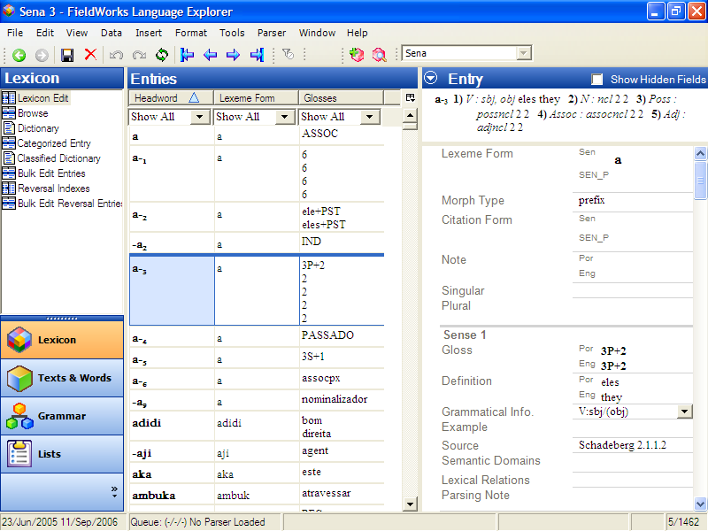
Navigation Pane area buttons
"Details" pane, here called Entry
Dictionary preview pane
Navigation Pane tools
Information bar
Status bar
"Center" pane, here called Entries

Areas
Language Explorer is organized around functional "areas" of language work. Within each area, specialized tools or views are available. When you start Language Explorer for the first time, the default area that you see is the Lexicon area. The Lexicon area is where you will record information on the lexemes of a language. This data can become the basis for a published dictionary.
Besides the Lexicon area, the other functional areas in Language Explorer are listed below. You can click each one and examine the area.
- Texts & Words: This is the area where you record, gloss, analyze (interlinearize) and chart text data. Also, you manage the morphological analysis of words. You can also view a concordance of any word that occurs in your text corpus.
- Grammar: This is the area where you manage inflection templates, grammatical categories, natural classes, and much more.
- Lists: This is the area where you edit the list choices presented for certain fields in the database.
In this manual, we will primarily be working with the Lexicon and Text areas since these are where the much of one’s data entry and editing are accomplished. The other three areas are beyond the scope of this manual. For more information about any of these areas, go to Language Explorer Help available in the Help menu.

Panes and Views
There are basically four different kinds of display panes, or views:
- Detail view: In a detail view, every field of a selected record is viewable. For example, the Entry pane in Lexicon Edit (shown above) shows every detail of the selected lexeme. Every field in a detail view is editable.
- Browse view: In a browse view, data is displayed in columnar fashion. Each column represents a field and every row represents a record. This view shows a lot of records at a glance. The Entries pane in Lexicon Edit (shown above) is a browse view pane. Note that most fields are not editable in browse views. When a record is selected, fields that are editable are white. The rest are shaded.
- Tree list view: Data that is organized in a nested or hierarchical structure is displayed in a tree list view. For example, the middle pane of Categorized Entry (shown below) displays an organized set of semantic categories. Data displayed in a tree list view is not directly editable. However, most list data can be edited in the Lists area, or using a menu command.
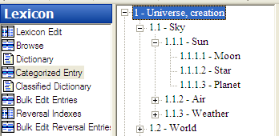
- Presentation view: In a presentation view, data is displayed as it will look when printed out. The Dictionary (in the Lexicon area) is a presentation view. Data cannot be edited directly in presentation views.
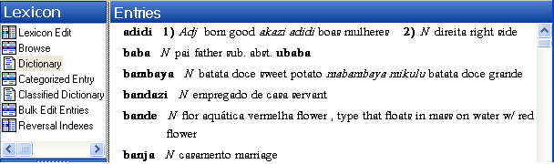

Different tools will use different combinations of these views. For example, Lexicon Edit has a browse view in the Entries pane, and a detail view in the Entry pane. At the top of the Entry pane there is the Dictionary Preview pane.
Feel free to explore at this point. Use the mouse to click one of the areas in the lower part of the Navigation Pane, and then click a tool associated with the selected area in the upper part of the Navigation Pane. Note the combination of different display panes and views in each tool.
For instructions on how to customize the layout of the Language Explorer screen, see Customizing Views and Navigation.

How to use this manual
This manual will help you get up and running using the basic features of Language Explorer. It is not a comprehensive instruction manual. For more detailed instructions on how to use a particular feature, consult Language Explorer Help or other supplied resources. (See Using Help and Other Resources.)
The best way to use this manual is to go through the chapters and exercises sequentially. You will be creating and developing a sample database as you go. Later exercises will assume you have already done earlier ones.
To give real-life context to using Language Explorer we created a fictitious researcher, Mark, who will be researching a real language, Sena.

Module SU: Setting Up a New Fieldworks Project
Mark is a linguist who is doing research on the Sena language. Sena is a Bantu language, spoken in Mozambique. The local language of wider communication is Portuguese. Mark will set up a FieldWorks project for Sena, designating Sena as the vernacular language under study, and Portuguese and English as analysis languages.
Course notes: Normally, in actual fieldwork, a researcher will only create one FieldWorks project for a given language being researched. However, for the sake of this training manual we will be dealing with several FieldWorks projects for Sena. You will create Sena 1 in this module and use it in most modules. However, in order to work with a larger database in later modules, we provide you with Sena 3. Sena 2 is also provided as a sample database. Because it is intended for use with other FieldWorks tools, it should not be changed.
Note that the Sena 3 database is based on an actual research project. Nothing is artificially contrived. You may notice numerous research notes and residue questions in various places in the data. These reflect the current state of analysis as of the date this software was released.
Follow the steps in this module to create a new FieldWorks project. Note, if you have already created Sena 1 in the process of learning another FieldWorks program, skip this module. You can simply open the Sena 1 project you created previously and go on to another module.
Once you have created the Sena 1 project, you can move on to another module; or if desired, exit the project.

Setting up a new FieldWorks project
      - To start Language Explorer, double-click the Language Explorer icon on the desktop.
- The very first time you do this, you will see the Training available dialog box. Click Yes to open Sena 3. Then you will see the Field Usage Report System dialog box. Click either the Create Email Message button or the I’m unable to send this information link, as appropriate.
The Sena 3 – Language Explorer window appears. After this initial startup, you will not see these dialog boxes again. Instead, the last project closed is the project that opens the next time you start Language Explorer.
In Language Explorer, you can create and open multiple FieldWorks projects. From this point on, the last FieldWorks project you close will be the one that appears the next time you start the FieldWorks Language Explorer program.

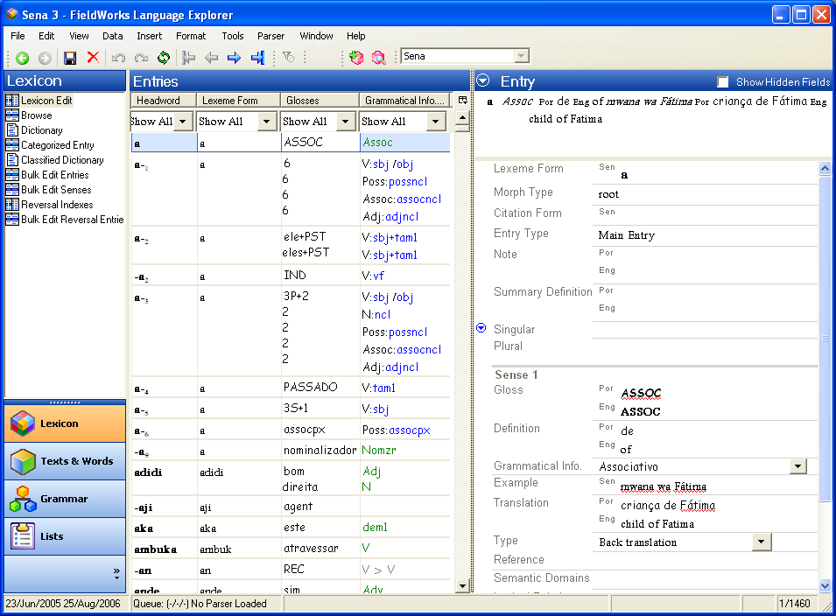

      - On the Menu bar, click File, and then click New FieldWorks Project.
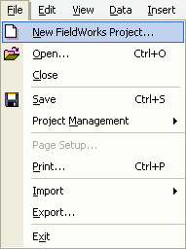

The New FieldWorks Project dialog box appears.
      - Type Sena 1 in the Name the project box
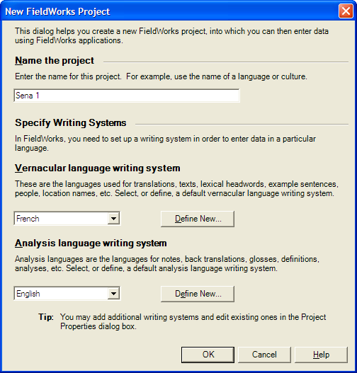

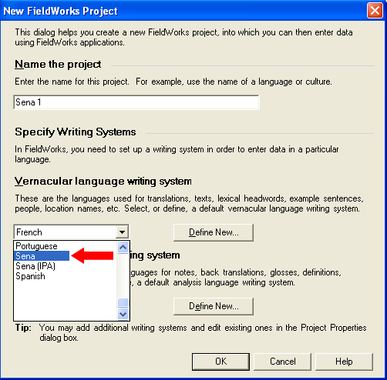

Mark will use a Vernacular language writing system that has already been defined in FieldWorks.
      - In the drop-down list, select Sena as the Vernacular language writing system.

Course Note: It is important to understand the distinction between a language and a writing system in FieldWorks. Every FieldWorks project is based on one, and only one, vernacular language. (The vernacular language is the one you are researching.) However, the vernacular language may be represented graphically by one or more writing systems. For example, one writing system may be based on IPA. Another may be the official orthography of the language. Another may be a traditional orthography. For simplicity in this manual, the Sena databases will only have one Vernacular language writing system associated with vernacular data. Note that the main Vernacular language writing system used in a project will likely have the same name as the language. In Sena 1, for example, Sena is the vernacular language we are researching. Sena is also the name of the writing system we are using to enter vernacular data.
For information about setting up a new FieldWorks project and also defining a new vernacular writing system, instead of selecting a writing system that has already been defined, see page 67.

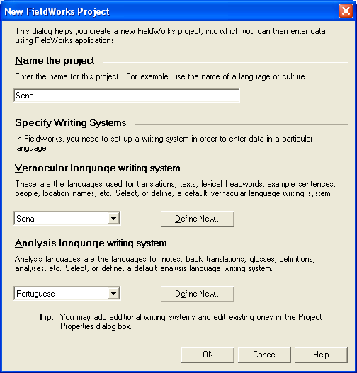
      - Mark will use Portuguese as one of the Analysis languages. So, in the drop-down list, select Portuguese as the Analysis language writing system.
      - Click OK.

An analysis language is a language in which you document analysis work, not the language that you are analyzing. You can select multiple analysis languages. In Language Explorer, glosses, definitions, and notes are in analysis languages.
Select a primary analysis language in which you express yourself well. For example, multi-cultural teams might use the language that all members know and teams with national members might use the national language.
In the Sena projects, the primary analysis language is Portuguese, and the secondary analysis language is English.
Note: The Portuguese writing system was installed with FieldWorks. If you have opened other FieldWorks applications on your computer, more writing systems might appear in the list.
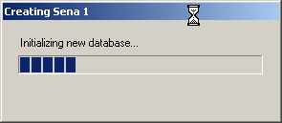
The system creates the new Sena 1 – FieldWorks project. Depending on the speed of your computer, this may take several minutes. The progress box shown here appears, as well as some others (briefly), and indicate the progress.

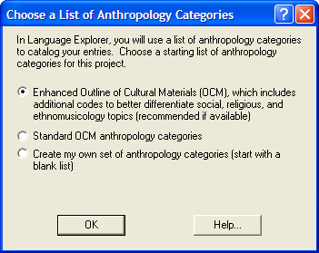
The Choose a List of Anthropology Codes dialog box appears. The set of anthropology codes you choose here will be available to you as you enter data into your lexical database. In this way you can tag your data by cultural category.

Enhanced Outline of Cultural Materials (OCM): This choice takes advantage of all the resources in the Outline of Cultural Materials. In addition, you will have available SIL’s FRAME categories that group the OCM under eleven higher-level divisions, and you will be able to use expanded categories on music, musical instruments, religion, and several other topics that are commonly elaborated.
Standard OCM anthropology categories: If you are already quite familiar with the OCM and do not envision expanding the codes, or plan on expanding them with your own additions, then you may want to use the Standard OCM anthropology categories.
Create my own set of anthropology categories: Select this option if you intend to enter your own anthropology category list, and do not ever plan to use the OCM in this project. Developing your own list of anthropology categories is easy to do badly and hard to do well. We do not recommend personal development of anthropology categories unless you have considerable experience in that area. Custom anthropology categories, while they can be developed for very specific research needs, will also limit the comparability of your data with other data sets.
Caution: You cannot change which list of anthropology categories are used after the project is created. For most users, the Enhanced Outline of Cultural Materials is recommended.
      - For this project, click Enhanced Outline of Cultural Materials.
      - Click OK.
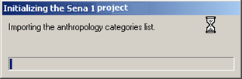
FieldWorks adds the list of anthropology categories to the Sena 1 project.

A Sena 1 Language Explorer window appears.

Course Note: The Sena 1 FieldWorks project has now been created and may be opened from any FieldWorks program. For example, if you also installed FieldWorks Data Notebook while installing the FieldWorks suite, you may start Data Notebook and open Sena 1 from Data Notebook’s File menu.
In other words, for a given language research project, you do not have to create a separate database for each FieldWorks program. All data for a particular project, no matter which program was used to create it, is stored in the same underlying database. Therefore, all the language and writing system settings and anthropology codes you set up for Sena 1 in Language Explorer will still be in place when you open Sena 1 from Data Notebook or Translation Editor. (You must have Data Notebook and/or Translation Editor installed in order to see this for yourself.) A fully shared database is part of the power of the FieldWorks suite of tools.

At this point, you have two projects open: Sena 3 and your new Sena 1.
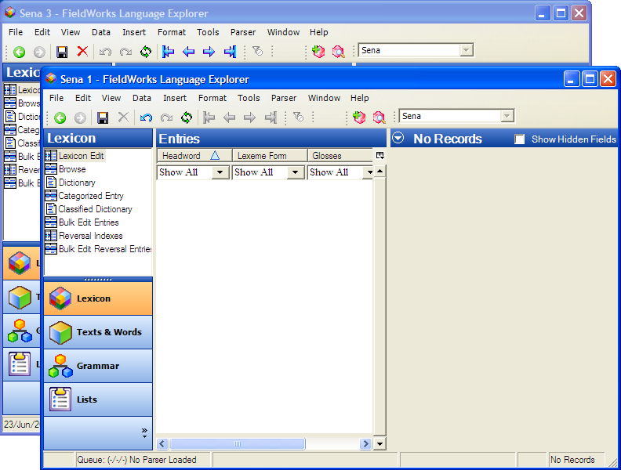

      - The program allows you to work with more than one open project. So at this point, you have two options: you may close the project called Sena 3 or leave both open. For the purpose of this course, close Sena 3 by clicking the Close button on the title bar with the name Sena 3.
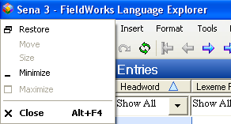
      - If you happened to close Sena 1 by mistake in the prior step, go to the next page for instructions on how to reopen Sena 1. If Sena 1 is open, maximize its window (), and then continue in Module ED - Entering Data.

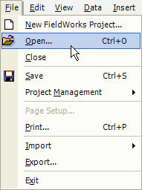
      - To reopen Sena 1:
On the File menu, click Open.

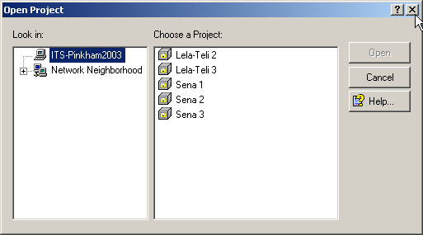
The Open Project dialog box appears.
      - Select the project you want to open by clicking it (Sena 1 in this example).
      - Click Open.

Course note: We suggest at this point that you maximize () the Sena 1 Language Explorer window.

Module ED: Entering Data
Entering language data into a FieldWorks project is easy. You do not have to know much about a language at all to start recording information in Language Explorer. As your knowledge of the language grows, your FieldWorks database can grow with you in both breadth and depth.

Creating a New Lexical Entry – a simple example
If you have your newly created Sena 1 project open in Language Explorer, you will see that there are no records in the database yet. As you will learn in this topic, creating records (lexical entries) in Language Explorer is very easy. You can create them without knowing "everything" about the entry.

Steps to create a new Lexical Entry
To illustrate how easy it is to create new entries, follow the steps below
- If necessary, open the Sena 1 project. Then in the Navigation Pane, click Lexicon and then click Lexicon Edit.
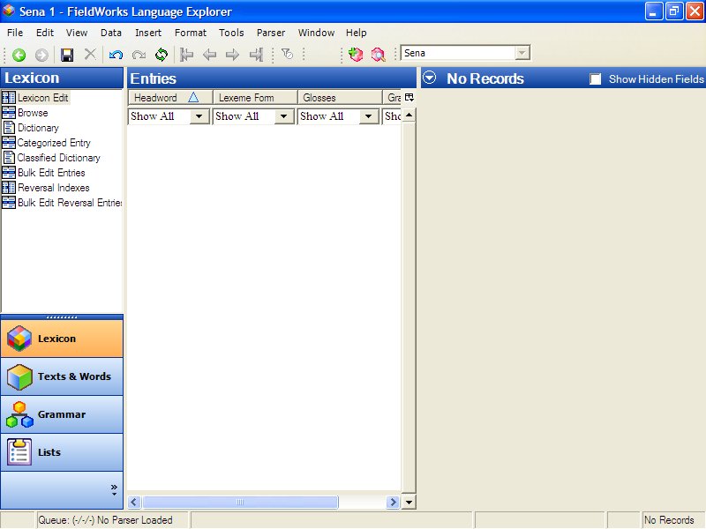
      - On the toolbar, click (Create a new lexical entry icon) with your mouse.
(Alternatively, you can use the keyboard shortcut, Ctrl+E.)
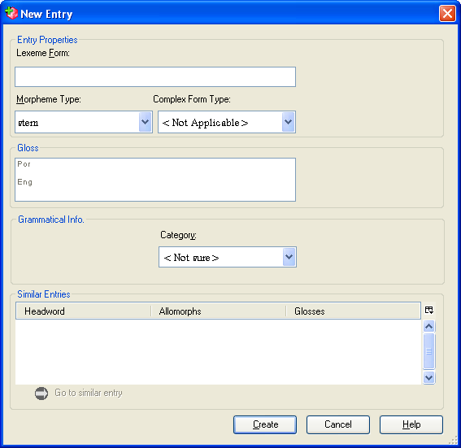
The New Entry dialog box
appears.

      - In the Lexeme Form field,
type myfirstlexeme.

      - Click the Create button at the bottom of the dialog box.
(Alternatively, press the Enter on the keyboard.)
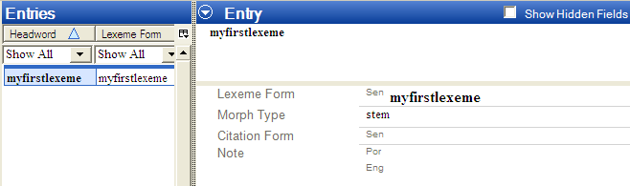
The new entry, myfirstlexeme, appears in the Entries pane (center of the screen) and in the Entry pane (the side right of the screen).

This lexeme is now in your database. It is as simple as that.
Of course, this entry not something we want in the Sena 1 project. So, let's delete it.

Steps to delete a Lexical Entry
      - Using the mouse, click the Delete icon on the toolbar.
(Alternatively, press Ctrl+Del on the keyboard.)
The Delete Entry dialog box appears. Language Explorer presents you with a caution statement letting you know exactly what will be deleted when you click the Delete button. In this case, it should say that myfirstlexeme will be deleted. This is what we want.
      - Using the mouse, click the Delete button at the bottom of the dialog box.
(Alternatively, press the Tab key until the Delete button is highlighted, then press Enter.)
The lexeme, myfirstlexeme, is deleted and no longer appears in the Entries or Entry panes.

Creating a New Lexical Entry – a realistic example
During his first week among the Sena people, Mark was invited to participate in transporting rice during the rice harvest. Listening to conversations, he began to learn some words and phrases. Mark wrote these down on a small pocket sized notebook to enter in his database later.
That evening at home, Mark recorded the information from his notebook (and from memory) into his FieldWorks project.
One of the words Mark learned was a term for farmer.

Steps to create a new entry using the mouse
- If necessary, open the Sena 1 project. Make sure you are in the Lexicon by clicking the Lexicon button in the Navigation Pane. Also, make sure you are in Lexicon Edit by clicking the Lexicon Edit icon under Lexicon at the top of the Navigation Pane.
      - Click on the toolbar, or on the Insert menu, click Entry.
The New Entry dialog box appears.
      - In the Lexeme Form box, type mulimi.
      - At this point, Mark was not sure whether this word is a root or a stem. However, Language Explorer does not require that he know this initially. So for now, he left the Morpheme Type as the default, a stem.
Course Note: If you like, you can click the down arrow in the Morpheme Type box to see the list of choices available.
Language Explorer is aware of most morpheme types that occur in languages.
      - Mark thought this word is a noun in Sena, so he selected noun in the Category box.
With the mouse, click the down arrow in the Category box in the Category Info. area. In the list, click the noun. Alternatively, use the Tab key to move the insertion point into the Category box, and then type an n. If necessary, use the down arrow key to move to Noun (if there are other categories, such as negator that appear before it). Press Enter.
Course Note: Mark could just as well have left the Category field <Not Sure> if he really could not tell at this point. For example, from Mark’s limited understanding, mulimi might be a noun, or it might be a verb. Only further analysis will reveal this. Whatever Mark chooses to do here, he can easily edit this field later when he finds out for sure.
Notice in the Gloss box there is a line for both a Portuguese gloss (Por) and for an English gloss (Eng). This is because we set both Portuguese and English as Analysis Writing Systems for the Sena 1 project.
      - In the Por gloss line, type lavrador. Then, click the Eng line and type farmer.
      - Click the Create button.
Mulimi is now a lexeme in Mark’s Sena 1 database.

Steps to create a new entry using the menu and keyboard
Mark also learned a term for rice. He entered it into his lexical database using the keyboard rather than the mouse.
- If necessary, open the Sena 1 project. Make sure you are in the Lexicon area by clicking the Lexicon button in the Navigation Pane. Also, make sure you are in the Lexicon Edit tool by clicking Lexicon Edit at the top of the Navigation Pane.
      - Press Alt+I and E (underlined letters feature for menus), or press Ctrl+E (shortcut keys feature).
The New Entry dialog box appears. The cursor should already be in the Lexeme Form box.
      - In the Lexeme Form box, type mpunga.
      - Press the Tab key.
The contents of the Morpheme Type field are highlighted, and contains stem. If we wanted to change the morpheme type, we could type the first character of the morpheme type we wanted until it appears in the Morpheme Type field. However, for this entry, stem is the correct morpheme type.
If you wish to experiment, go ahead and type r. The Morpheme Type, root will appear in the box. Type the hyphen character ‘-‘ repeatedly and notice what appears in the box each time. Different types of affix will appear from the list of Morpheme Types. When you are finished experimenting, type s. This will bring stem back into the box, which is what we want for now.
      - Press the Tab key to select (highlight) the contents of the Category Info. pane's Category box.
      - Type N.
The Category chooser list drops down with N highlighted. We will keep this choice for noun.
      - Press Enter to confirm this choice
      - Press the Tab key again.
The cursor moves to the Gloss box, next to Por. (the abbreviation for Portuguese.)
      - Type the Portuguese gloss arroz.
      - Press the down arrow key.
The cursor moves to Eng.
      - Type the English gloss, rice.
      - Press Enter again to create the entry.
The New Entry dialog box closes and the new entry mpunga appears in the Entries and the Entry panes.
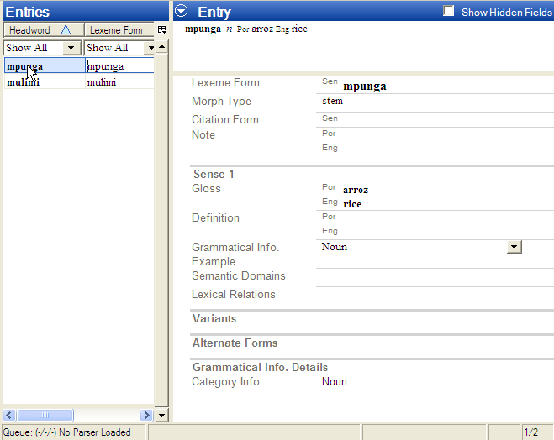

Adding New Senses
So far, we have simply added two lexemes to the Sena 1 database. Notice in the Entry pane that for the lexemes we have entered the Gloss and Grammatical Info. field information is under Sense 1. You can easily add more senses to entries in Language Explorer. In this section, we will create another lexical entry and add a second sense.

Add the new entry
One day, Mark was at the outdoor market when he saw a man having his hair cut. Then Mark learned the verb for that action.
If necessary, open the Sena 1 project. Make sure you are in the Lexicon area by clicking the Lexicon button in the Navigation Pane. Also, make sure you are in the Lexicon Edit tool by clicking Lexicon Edit at the top of the Navigation Pane.
      - In the New Entry dialog box (Ctrl+E), do the following:
- Enter the lexeme form cinga.
- Select stem for the Morpheme Type.
- Enter the Portuguese gloss cortar cabelho and the English gloss cut hair.
- Type V in the Category field and select verb as the category.
- Click the Create button.
The resulting lexical entry should show up under Entries and Entry, as did mpunga and mulimi in previous exercises.

Discover a new sense
Several weeks later, Mark learned the word for shaving one’s beard. It also happens to be cinga. However, at the time he did not make the connection with the verb for cutting hair. Later that day he started to enter this “new” word into his database the way he has done with all his new entries.
- If necessary, open the Sena 1 project. Then, in the Navigation Pane, click Lexicon and then click Lexicon Edit.
      - Open the New Entry dialog box (Ctrl+E).
      - In the Lexeme Form box, begin typing cinga.
Notice that even before you finish typing, cinga appears in the Similar Entries pane near the bottom of the New Entry dialog box.
As he was typing in the Lexeme Form field, Mark noticed that cinga is already in his database and that the gloss is cortat cabelho (cut hair). He decided that what he discovered was not a new word after all, but a new sense of a word he had already recorded. Mark brought up the lexeme, cinga, using the Go to similar entry link. He then added a new sense to it.
Obviously, with only three entries in Sena 1 so far, it is easy for us to see directly that cinga is already in the database. However, imagine if we actually had several hundred entries by now. Having Language Explorer display Similar Entries is very helpful in discovering whether your “new” entry is actually another sense of a current entry, or perhaps even a homonym.
      - Select cinga in the Similar Entries field by either clicking it with the mouse or pressing the Tab key several times until cinga is highlighted.
      - Click the Go to similar entry link at the bottom of the Similar Entries pane.
Language Explorer will take you to the entry, cinga, which is now be highlighted in the Entries pane and displayed in the Entry pane.

Add the new sense
      - With the entry, cinga, displayed in the Entry pane, click the Sense 1 label.
Notice a menu button appears to the left of Sense 1 label.
      - Click the menu button.
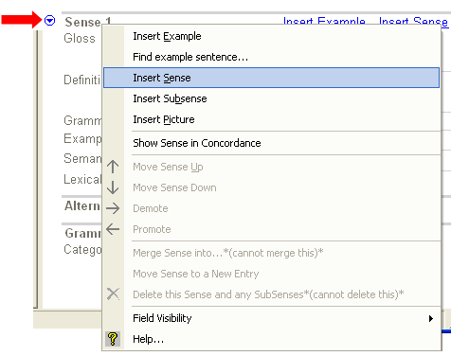
A menu appears.
      - On the menu, click Insert Sense.
A new sense, Sense 2, appears just below Sense 1 in the open window.

      - In the Gloss field, click the Por (for Portuguese) line, and then type barbear.
      - Press the down arrow key on your keyboard to move to the Eng (for English) line, and then type shave.
      - The Grammatical Info box should already show Verb. (If not, click the down arrow in the Grammatical Info box, and then select Verb from the list.)
You have just added the new sense.
Actually, it was added to the database in step 3 above. It just did not have any data in it yet. Also, note that Language Explorer records information into the database as you type. There is no need to invoke a “save” command.

Entering Semantically Categorized Lexical Data
After nine months living with the Sena people, Mark has made a number of friends and can speak the language well enough to organize a word-collection workshop. He invited six people who seem well adept at talking about their language. Over the course of a week they listed about 10,000 words, all keyed to a predefined schema of semantic categories. With the help of a typist, Mark entered these words into his Sena database. He used the Categorized Entry tool to do this efficiently.
After having entered several new entries using the New Entry dialog box, you can see how tedious this would be for a list of 10,000 new words! However, if those words are organized according to semantic domains, the Categorized Entry tool makes this an efficient process. (For more information on running a semantically categorized word-collection workshop, go to http://www.sil.org/computing/ddp/. )

Steps for entering words using Categorized Entry
- If necessary, open the Sena 1 project.
      - In the Navigation Pane, click Lexicon and then click the Categorized Entry tool in the list of tools under Lexicon.
The first time you do this an information box pops up. If you do not want to see it again, select the check box that says, “Don’t show this again,” and then press Ok.
The Categorized Entry tool is displayed. The middle pane displays a nested list of semantic domains. The Semantic Domain pane displays questions to help elicit words, which you enter in the Words for <domain> pane.
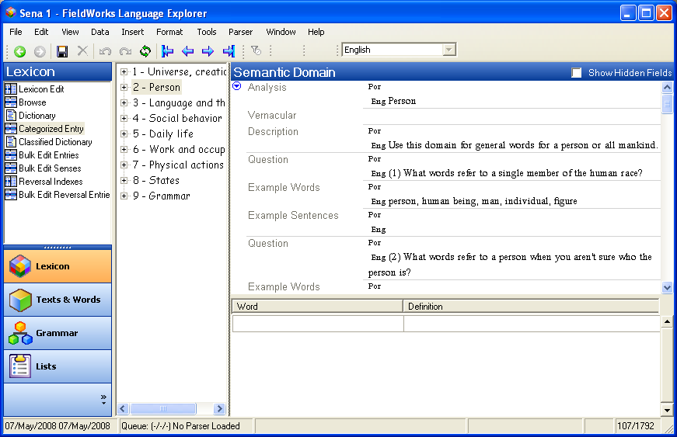

(If the list of semantic domains is obscured by the Semantic Domain pane you can move the leftmost border of the Semantic Domain pane to the right using the mouse. Hover the mouse over the border until you see the resize arrow. Then click and drag the border until you can see the semantic domain list clearly.)
      - Go to the semantic domain for furniture, as follows:
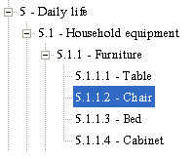
- In the middle pane, expand the outline for 5 -Daily life by clicking the plus sign. Then, expand 5.1 - Household equipment, and 5.1.1 - Furniture.
- Click 5.1.1.2 – Chair to select it.
Notice that the semantic domain for chair is in focus in the Semantic Domain pane.
      - In the lower right pane, click the empty field in the Word column.
      - Type kadera, and then press Tab to move the cursor to the Definition column.
      - In the Definition column, type cadeira, and then press Enter.
(Note that since Portuguese is the primary analysis language, information you type in the definition field will go into the Portuguese definition field in the lexicon.)
You just entered a Sena word and Portuguese definition into your lexical database. A new row is added and the cursor appears in an empty cell in the Word column.
      - Enter the following words and definitions using the Tab or Enter keys to navigate in the columns and rows.
Word | Definition
mpando | banco
kaciti | asento
banku | banco
You should have four words and definitions listed under Words for 5.1.1.2 – Chair.
      - In the Navigation Pane, click Lexicon Edit.
The four words you entered are now lexical entries. Click one of them in the Entries pane, and look at the various fields in the Entry pane.
Notice that the Lexeme Form, Definition (under Sense 1) and Semantic Domain each have content you entered in the Categorized Entry tool. Further, Language Explorer automatically chose the default Morpheme Type, stem and Entry Type, Main Entry.
Lexical entries can be entered very quickly in this manner, but there are basic fields in these entries that need to be filled in. These may also be filled in efficiently using the Bulk Edit tools, as we shall see in another module. (See Editing Data Using Bulk Edit)

Entering Text Data – basic steps
Entering, editing and deleting text data is as easy as typing. In the following exercise, you will create your first texts, edit them and then delete them.

Steps for entering and editing a text for the first time
- If necessary, open the Sena 1 project.
      - In the Navigation Pane, click Texts & Words. Interlinear Texts should be selected at the top of the Navigation Pane, but if not, click it now.
Two empty panes appear on your screen to the right of the Navigation Pane: the Texts pane in the middle and the Text pane on the right. In the Text pane, notice the tabs under the Title box.
      - Click the Baseline tab to open the space where you enter and edit the text.
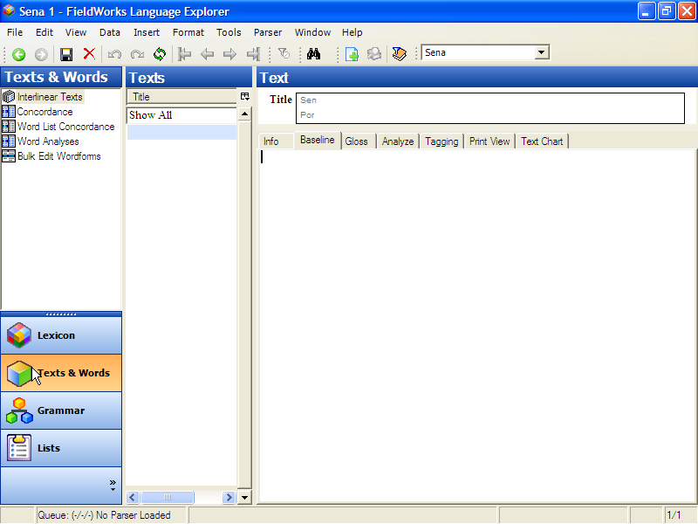

      - Click anywhere in that empty space in the Baseline tab, and then type This is my first text.
(Alternatively, type anything you wish. It does not matter for this exercise.)
You have just entered text data into your Sena 1 database.
Language Explorer saved your text data to the database as you typed it. You can verify this yourself by closing Sena 1, then opening it again, and looking in the Texts area.
Now give your text a name:
      - In the Title box, click the Por (for Portuguese) line, and then type First text.
Your text now has a name. If the title you just typed did not appear in the Texts pane, click the Refresh icon on the toolbar.
(Alternatively, click Refresh on the View menu, or press F5 on the keyboard.)
In Language Explorer, you may have many texts, each one recorded under its own title. The Texts pane contains a list of all your texts, sorted by title. Now you only have one text.
Now edit your text:
      - You can easily edit the text, using cut, copy and paste common to most word processors. For practice, click just after last word in the Baseline tab, and then type that I have entered into Language Explorer.
Note that you can create complications that may cause you some rework if you are not careful with baseline text writing systems. This is discussed in the User Helps.

Add a new text to your text corpus
      - Click on the toolbar to create a new text.
(Alternatively, click New Text on the Insert menu, or press Ctrl+T on the keyboard.)
      - In the Title box, type Second text in the Por line.
      - In the Baseline tab, type This is my second text.
      - If necessary, refresh the screen (F5) to see the titles of both texts in the Texts pane.
Note that the text you see in the Text pane is the one whose title is highlighted in the Texts pane.

Delete a text
      - In the center Texts pane, click First text to bring it into focus.
      - Click the on the toolbar.
(Alternatively, click Delete Record on the Edit menu, or press Ctrl+Del on the keyboard.)
A warning box appears describing what will be deleted if you continue.
      - Click Delete.
First text is deleted and no longer visible in the Texts pane.

Entering Text Data – a realistic example
While learning Sena, Mark recorded a sentence and decided to save it as a text in his database. He also recorded some information about this text in the Comment field on the Info tab.

Steps to add Mark’s text to the Sena 1 database
- If necessary, open the Sena 1 project. In the Navigation Pane, click Texts & Words. Then, click Interlinear Texts.
      - Create a new text by following the steps for Add a new text to your text corpus above.
      - Click the Baseline tab and type (or copy and paste) Pisapha, mbwenye pinafunika n'khuphata ntima. Tonsene njira yathu ndjeneyi.
      - In the Title box, click the Por line, and then type Tenha coragem (which means, "Have courage"). Then, click the Sen line, and type Phatani ntima.
If necessary, refresh the screen (F5) to see the title in the Texts pane.
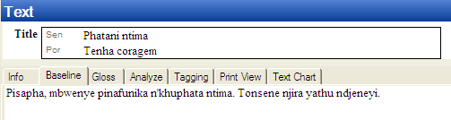

      - In the Text pane, click the Info tab, and then type, "Collected by Mark on 3/5/06 from Tito Anju in Vila de Caia" in the Source field. For this exercise, you can type (or paste) it in either the Por or Eng line.
      - In the Comment field, type or paste "Phatani ntima" ("Have courage") (c) Luís Nyazeze, used by permission. "
As you can see, as far as Language Explorer is concerned, a text can be as short or as long as is useful to your analysis. Normally a text will be a whole discourse unit rather than just a sentence or phrase long. The basic elements of a text record are: the text itself, which is recorded in the Baseline tab; the title and other metadata, which may be written in vernacular and analysis writing systems in the Title field and in the Info tab.
Mark decided to gloss this text by adding word glosses, to the extent of his current knowledge. At this point, he understood what the whole sentence meant, and he knew most of the words. However, he did not know how to parse the words into individual morphemes yet.

Steps to interlinearize a text
Since Mark did not know all the details to break words down into morphemes, he decided to only fill in the word glosses and add a free translation. The simple view is shown in the Gloss tab. It shows the Word Gloss and Word Cat. lines and the Free Translation lines. He will not add the word grammatical categories now.
      - Make sure the text titled Phatani ntima is open in the Text pane by clicking it in the center Texts pane.
      - In the Text pane, click the Gloss tab. A message box named Add Words to Lexicon appears. Make sure the check box is clear (no check mark), and then click OK.
(This feature is useful for monomorphemic languages.)
The text appears with several analysis lines inserted below.
      - On the Tools menu, point to Configure, and then click Interlinear.
- In the Configure Interlinear Lines dialog box, click Free Translation in the Available Lines pane and then click Show>>. A second Free Translation line appears in the Displayed Lines pane. In the Writing System box, select English. Now you will have two sets of Free Translation lines, one for Portuguese and one for English.
- While this dialog box is open, click the Word Gloss line in the Displayed lines pane. Then select English for this line in the Writing System box. For our exercises, we will enter word glosses in English.
- Click OK to close the dialog box.
      - Click the space to the right of the top Free pt label in the Gloss tab, and then, type, “‎Estas coisas doem mas o que é necessario é ter coragem. Pois nós todos vamos morrer.”
Click to the right of the second Free en label, and then type, “These things hurt but what is necessary is to have courage.”
In the second line of text, indicated by the 1.2 at the left edge, we only have currently an English free translation, so in the Free en line type, "For all of us will die."
Your window should look like this:
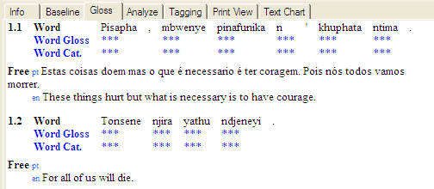

Steps to interlinearize a text – add word glosses
      - Click the word pisapha.
Language Explorer places a box around the word and the associated analysis lines.
For our purposes, we will refer to this box as the "word focus box". Since one interlinearizes text one word at a time, the focus box will only encompass one word at a time. Within the word focus box, fields and controls become available to fill in each analysis line.
      - Click the Word Gloss box and type, "these things hurt". Then, click the green check mark and then click the Word Gloss box for the next word, or press Ctrl+Enter.
      - Repeat steps 1 & 2 for the following words in the text:
Word | Word Gloss
mbwenye | but
pinafunka | what is necessary
n’khuphata | is to hold
ntima | heart
tonsene | all of us
njira | path
yathu | our
ndjeneyi | is really this one
Tip: When you are at the last word in the line, here
ndjeneyi, when you click the green check mark or press Enter, the word focus box does not move as before. However, you can see that the changes were saved by the fact that the undo arrow that previously appeared next to the green check mark has disappeared.

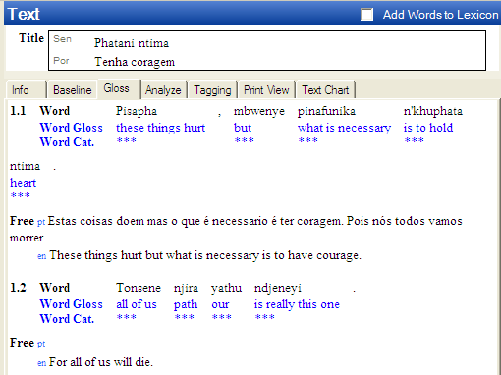

Your Gloss pane should look like the example above.
As you can see, Language Explorer does not require you to know everything before you enter text data. It allows you to fill in information as you learn – at your pace. Of course, all of the information that you enter is editable. Therefore, as your knowledge of a language becomes more refined, your glosses may be fine tuned, and so on.

Steps to interlinearize a text – enter new lexemes to the lexical database
Some time later, after sufficient analysis, Mark found out how to parse a few words from this text into constituent morphemes. He analyzed these wordforms and added the morphemes to his lexical database.
      - In the Text pane, click the Analyze tab.
This view defaults to show the morphological analyses lines as well as those shown in the Gloss tab.
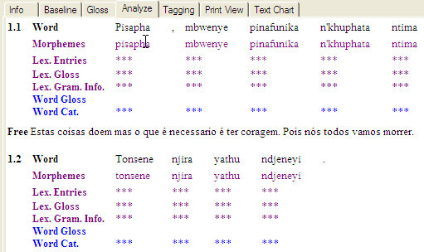

      - We need to configure the interlinear lines for this tab also. So on the Tools menu, point to Configure, and then click Interlinear.
- In the Configure Interlinear Lines dialog box, select the Word Gloss line in the Displayed lines pane, and then select English in the Writing System box.
- In the Available lines pane, click Free Translation, and then click Show >>. Then, select English for that line in the Writing System box.
- Click OK to close the dialog box.
      - Click the word pisapha and notice the word focus box encompasses the word and its analysis fields. Notice that this looks similar to the word focus box you saw in the Gloss tab, except that there are additional lines shown.
      - Click the down arrow to the left of the Morphemes field, and then select Edit Morph Breaks.
The Insert Morpheme Breaks dialog box appears.
      - In the Word box, insert hyphens and spaces as described in the Break Characters pane in this way: pi- sa- ph –a. Click OK.
Notice that the Morphemes line expanded to show the individual morphemes separately.
      - Click the down arrow to the left of the Lex Entries field for root ph, and then select Create New Entry.
The New Entry dialog box appears. Notice that ph is already in the Lexeme Form line, and stem appears as the default Morpheme Type. Select root in the Morpheme Type box.
      - In the Category Info. area, Category box, select Verb. Then, in the Gloss: box, type the Por gloss fazer doer and the Eng gloss hurt.
      - Click Create.
The word focus box shows the lexeme form of the root ph, the lexeme English gloss hurt and the word gloss.
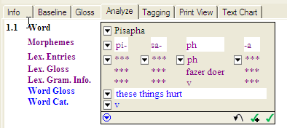
Your word focus box should look like this at this point in the analysis:

The New Entry dialog box that is accessed from the focus box is the same dialog box that appears when in the Lexicon area using Lexicon Edit. When you enter lexical data in the course of interlinearizing text, this data is recorded in your lexical database. To see this for yourself, go to the Lexicon and click Lexicon Edit. Look in the Entries pane and see that the new lexeme <lexeme> appears just as you entered it while interlinearizing text.

Tagging a text
Mark noticed that the possessive adjective yathu comes after the noun that it modifies. He wants to tag these two words as a noun phrase.
      - In the Text pane, click the Tagging tab.
This view is similar to the Analyze view, but does not show a word focus box.
      - As before, we need to configure the interlinear lines for this tab. So on the Tools menu, point to Configure, and then click Interlinear.
- In the Configure Interlinear Lines dialog box, select the Word Gloss line in the Displayed lines pane, and then select English in the Writing System box.
- Click OK to close the dialog box.
      - Select the two words njira yathu, then right-click on one of them.
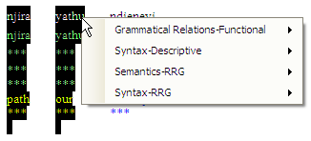
You should see this context-sensitive menu:

      - In the Syntax-Descriptive section, select Noun Phrase.
You will now see a display like this:
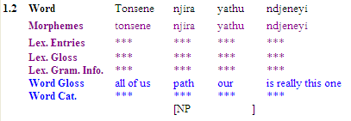
We have finished covering the basics of lexical and text data. You can learn more by browsing the Help files according to your particular needs. You can access Language Explorer Helps using the Help menu, or using the Start menu: Start_All Programs_FieldWorks_Language Explorer_Language Explorer Help.

Module DC: Discourse Chart (Text Chart tab)
After analyzing the text, you can insert the words in that text into a discourse chart or text chart using the Text Chart tab.
The chart has rows and columns. Each row is a clause. Columns are arranged as pre-nuclear, nuclear and post-nuclear groups, where the nuclear group contains the subject, verb and object/complement. If the sentence structure of the vernacular language you are working with is different, that is not SVO, the columns may be reordered. However, we will not do this in this exercise. (Refer to the User Helps for more information).
When the chart has content, the left column displays numbers that identify sentences and paragraphs, and letters that identify clauses within each sentence. Different line weights are used for the horizontal lines to indicate the end of clauses (lightest), sentences (mid-weight), and paragraphs (heaviest). The right column is an editable Notes field.

Practice inserting text into the chart
- If necessary, open the Sena 1 project. In the Navigation Pane, click Texts & Words. Then, click Interlinear Texts. Then, click the Text Chart tab.
Notice that vernacular interlinearized words from the selected text appear near the bottom of this tab. Below the vernacular word is the word gloss, if you had entered or selected one.
The first vernacular word is always selected and ready for insertion into the chart. When it is appropriate, you can select additional subsequent words.
Notice too, that each column (Outer, Inner, Subject and so on) in the Text Chart tab has a pair of buttons located at the bottom of the column. The larger button has the column name and an up arrow () and its associated button has only down arrow (). You click the button with the up arrow to simply insert the selected word into that column. You click the button with a down arrow to access other options for inserting the word into the chart.
To see the results of the various options, do each of the following and notice the results (do not concern yourself at this time with being correct regarding which columns you insert the various words):
- Click the button with an up arrow () at the bottom of the column into which you want to insert the selected word to put it in the currently lowest row.
- Click the button with a down-arrow () and then select Insert into new Row to insert the selected word into a new row, which is a new clause.
- Click the button with a down-arrow (), point to Insert as Moved from, and then select the desired column. This inserts the words into the chart in an order other than their default word order. The word(s) appear in the column you selected, and a preposed from or postposed from marker appears in the default column.
After you have tried each of the insertion options, let’s review the menu commands that appear when you click a word in the chart. First, make sure that you have words in a number of rows (clauses) and at least one word in each column. Insert words as necessary, but do not concern yourself with being correct.
You should see numbers and letters in the left column (such as 1a, 1b, 2 and so on). If not insert more words into the chart with each of the options listed above.

Practice with Text Chart menu commands
A context-sensitive menu appears when you double click any word in the chart. Some of the menu commands have context-sensitive cascading menus. We will not practice with every possible command and cascading menu option, but will instead experiment with enough of them to help you learn the various ways you use them. Do not be concerned with being correct, but instead be observant to notice the effects of using the various commands.
Let’s begin by marking rows as the last row in the sentence and last row in the paragraph.
      - Double click (or right click) any word that is in the chart and notice the menu that appears.
Note: When you click a word once, a menu button appears. To see the menu, you can do any of the following: click the menu button, click the word again, or right-click the word. Any of these bring up a menu with the same commands.
      - Click the Last Row in Sentence command in the menu.
- Notice that the weight of the horizontal line changed and that the numbers and letters in the left column changed.
- Double click the same word again and notice that the Last Row in Sentence command has a check mark. Click any other row to clear the menu from the screen.
      - Double click another word in a different clause (row) and then, click the Last Row in Paragraph command in the menu.
- Notice that the weight of the horizontal line changed to an even heavier weight, and that the numbers and letters in the left column changed.
- Double click the same word again and notice that the Last Row in Paragraph and the Last Row in Sentence commands each has a check mark.
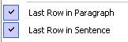
You can click a menu command that has a check mark to clear that check mark from the menu. Clearing a check mark removes the effects of that command.
- Right click (or double click) the last word that you clicked, and then click the Last Row in Paragraph command to clear the check mark from that command.
- Notice that the line weight changed to indicate that the clause is now only the last row in the sentence.
Next, let’s practice with marking a word as preposed. (You marking words as postposed the same in a similar way.)
      - Double click any word in the text chart, and then hold your mouse pointer over the Mark as Preposed from command and then over the Mark as Postposed from command.
- Notice the various options in the two different cascading menus that appears. These are the available columns.
The Mark as Preposed from command displays the columns that appear before the current word, and the Mark as Postposed from command displays the columns that appear after the current word.
- Now, double click different words in different columns and again observe the available commands on the menu and the options on the cascading menus change depending on where in the chart you clicked.
The point here is to notice that both the menu and the cascading menu are context sensitive. If for example you double click the first word in the top row, notice that the Mark as Postposed from command is not displayed.
      - Double click any word in the pre-nuclear Inner column (appears before the Subject column). Point to the Mark as Preposed from command, and then select Subject on the cascading menu.
- Notice that the word marked as preposed (in the Inner column) became red in color. Also, notice that a pink marker << appeared in the Subject column, which indicates the default position of the preposed word.
- Double click the word that is marked as preposed (is red in color). Point to the Mark as Preposed from command, and notice that the Subject option on the cascading menu has a check mark.
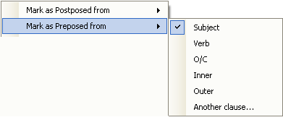
- Click Subject again to remove the check mark and the various markings from the chart.
Next, let’s practice the steps for making dependant clauses. (You make song clauses and speech clauses in a similar way. Different colors appear to indicate the type of clause.)
      - Double click any word in the text chart, and then hold your mouse pointer over the Make a Dependant Clause out of the command. Notice the options in the cascading menu that appears.
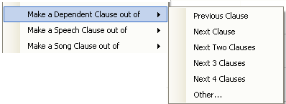
Note: If you had double clicked a word in the first clause, then Previous Clause would not appear as an option in the cascading menu. Similarly, if you had double clicked a word in the last clause, then Next Clause would not appear in the cascading menu.
      - In the cascading menu, click Next Clause.
- Notice that the next or previous clause turned blue in color and is now between square brackets [ ].
- Notice too, that a clause marker appears in the cell with the word you double clicked. The clause markers are blue as well, and indicate the sentence number and clause letter on which the word is dependant. The clause marker, could appear as this example [2a], indicating that word is dependant on the first clause (the “a”) in the second sentence (the “2”).
      - Click the word that has the clause marker. Examine the commands in the menu.
- Notice that the Make a Dependant Clause out of the command has been replaced with a Remove Clause Marker command.
- Click the Remove Clause Marker command. Notice that the clause marker, the blue colors and square brackets are removed from the chart.
The Make a Song Clause out of and Make a Speech Clause out of menu commands function in the same way. You can experiment with them if you want, noticing that the colors are different.
Next, let’s practice with the menu commands Move Word and Move Cell. First, a brief overview:
- Each of these menu commands has a context-sensitive cascading menu with Forward and Back, unless the word is already at the very end or beginning of the chart.
- Move Word moves one word to an adjacent cell, either forward or backwards.
FieldWorks preserves the word order. If, for example, you click a cell with two words and select Move Word…Forward, only the last word in the cell will move. If you select Move Word…Back, only the first word will move from the cell. Correspondingly, if you move a word into a cell that already has a word, the word order is preserved in that cell.
- Move Cell moves the entire content of a cell (one or more words) to an adjacent cell, either forward or backward. The word order is preserved.
If you move a word or cell forward from the last column in the clause, the word or cell contents move down to the next clause. If you move a word or cell back from the first column in the clause, the word or cell contents move up to the next clause.
Neither of these two menu commands change the color of the moved words or add any markers. The words just simply move.
To experiment with these commands, do the following:
      - Right-click (or double-click) any word in the chart, point to Move Word, and then select Forward.
- You can move the same word more than one time.
The first time you select Move Word…Forward on the menu, that command is remembered, so you can use Ctrl+Right Arrow on the keyboard to make subsequent moves for that word. Similarly, for subsequent Move Word…Back, you can use Ctrl+Left Arrow on the keyboard.
- When a word is at the end of the current row (that is, it is in the last column of the current clause), it will move forward to the next row, unless at the end of the chart.
      - Use Move Word…Forward with various words until you have two or more cells that contain multiple words. Then, do the following:
- Double-click one of the cells with more than one word, then select Move Word…Forward.
Notice that to preserve the word order only the last word in the cell moves to the adjacent cell. If that adjacent cell already had content, then the moved word appears as the first word in that cell.
      - Right-click a cell that has more than one word, and then select Move Cell….Forward.
Notice that the entire contents of the cell moved, not just one word. Notice too, that the words were moved to the front of receiving cell to preserve word order.
Next, let’s consider the menu commands Mark TenseAspectMood, Mark Pronouns and Mark Demonstratives.
These menu commands and their cascading menus can be extensive, as shown in the example below:
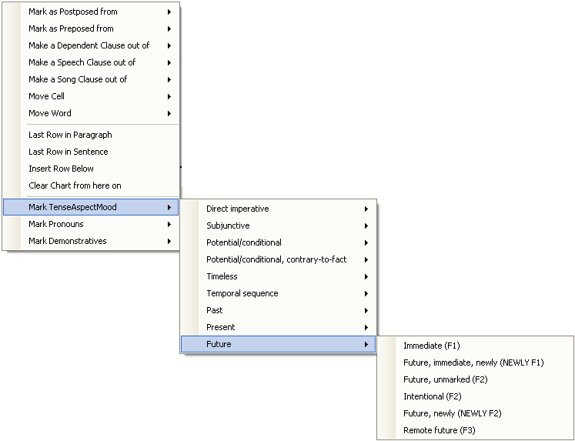

All of these chart markers are stored in the Language Explorer Lists area and are user-editable.
- To mark a word with any of these, do the following:
- Right-click (or double click) a cell, point to the desired menu command(s) to display the cascading menu. Then, click the desired marking.
Notice that the abbreviation of the marker, appears in the cell. For example, if you selected Mark TenseAspectMood…Future…Immediate, then (F1) appears in the cell. Also, in the cascading menu, a check mark is added to marker, such as in this example:
- To remove a marker from the cell, right-click (or double click) the cell that has the marker you want to remove. Then navigate to the cascading menu where that option is selected, and then click it again to remove the check mark. This removes the marking from the chart.
Module BR: Using Backup and Restore

Backing up a FieldWorks project
Mark knows that protecting his data from computer failure or file corruption is critical. He does this by backing it up regularly. FieldWorks offers several ways to manage regular backups. You can configure it to automatically back up your project according to a set schedule. Alternatively, you can have FieldWorks remind you to do this manually yourself. Of course, you do not have to wait for a scheduled time to backup your project. You may manually backup your data at anytime.
When thinking about backup strategies and archiving data, you should consider the following factors:
- It is wise to periodically save your backups to an external medium (for example, CD drive or USB drive). Alternatively, you may choose to backup directly to an external medium.
- Backing up to a folder on your local disk (for example, the Backups subfolder in the My FieldWorks folder) is the fastest way to back up data. However, it will not protect your data from a hard disk crash.
- Your organization may have a repository where you should be sending copies of your backups. (Remember to notify the appropriate person in the organization of your password, if you have password-protected your backups.)
- Backing up in XML form is the safest way to archive data. Though it takes more disk space, the file itself is human readable. (The normal backup is a binary file and is not human readable.) This option is available in the FieldWorks Backup and Restore dialog box.
Aside from protecting your data, there are two other uses for making backups:
Porting data to another computer. The actual file that FieldWorks acts on as you enter and edit data is not user-portable. Simply copying a project file or folder to a CD will not work. If you want to put a copy of your project on another computer, the only way to do it is to Backup your project to an external medium, and then Restore the project on the other computer.
Creating restore points. There may be times in your analysis when you want to test an hypothesis, but you also want to easily get back to your starting point if the hypothesis does not work out. Creating a backup as a restore point can be very useful for this purpose.
Note: Backup and Restore acts on an entire FieldWorks project including data from all FieldWorks applications. For example, if you installed DataNotebook and had anthropology data for the Sena 1 project, backing up Sena 1 from within Language Explorer would also backup Sena 1 anthropology data that was recorded using DataNotebook.

Steps to back up data
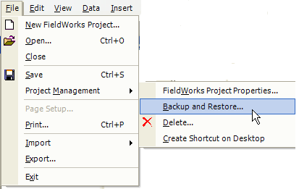
      - On the menu bar, click File.

      - Point to Project Management.

      - Click Backup and Restore.
The Backup and Restore dialog box appears.
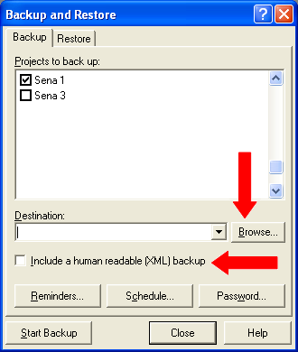

      - Select only the projects you want to back up.
      - Click the down arrow, or click Browse to select the drive and folder where you want the backup to be placed. It is best to choose the default Destination for backups. Keeping the backups in one place will make Restore easier
      - Select the check box only if you have a reason to include an XML file. It increases the time it takes to make a backup if you have a very large FieldWorks project.
      - Click Start Backup

Note: To change the frequency of reminders to back up, click Reminders. If you need help in the Backup Reminders dialog box, click Help. To schedule an automatic backup, click Schedule. If you need help in the Backup Schedule dialog box, click Help.

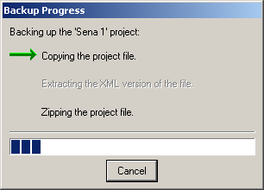
The Backup Progress dialog box appears.

When this dialog box disappears, the backup is finished.

Restoring a FieldWorks project

Steps to restore data
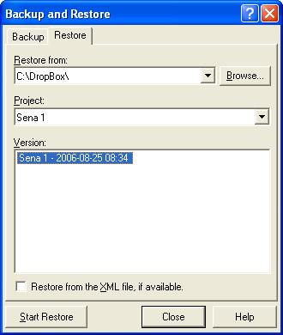
      - On the menu bar, click File.
      - Point to Project Management.
      - Click Backup and Restore.
The Backup and Restore dialog box appears.
      - Click the Restore tab.
      - In the Restore from box, navigate to the correct subfolder.
      - In the Project list, select the project that you need to restore back to a previous version.
      - In the Version list, select the date of the desired version to restore.
The Version consists of the FieldWorks project name, date and time of backup (time stamp). If you back up more than once in a day, make sure you select the file with the correct time stamp.
      - Click Start Restore.

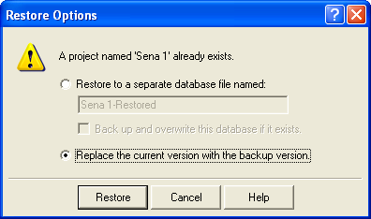
The Restore Options dialog box appears.

      - Click Replace the current version with the backup version.

      - Click Restore.

Note: When you replace the current version of the project, FieldWorks automatically backs the project up to the default backup folder, in case you decide to return to the current version of the project at a later time.
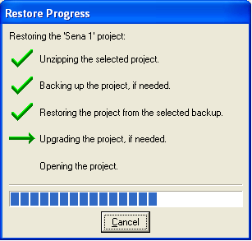
The Restore Progress dialog box appears.

When the project has been restored, Language Explorer opens the restored project.

Module VN: Viewing and Navigating Data
Language Explorer was designed to capture many details about a language’s lexicon, morphology and grammar. As such, there is a lot of information to display. In order to manage what you see at any given time the screen can be customized to meet your needs.

Adjusting Pane Sizes
For any given Language Explorer screen, the panes are divided by splitter bars. These bars are moveable to allow you to see more or less of the contents of a pane. For example, in the Lexicon Edit tool, dragging the splitter bar that separates the Entries pane from the Entry pane to the left will increase the detail view in the Entry pane and decrease the browse view in the Entries pane. In this way, you can allocate screen space according to the task you are working on.

Steps to adjust pane sizes – an example using Lexicon Edit
- Open Sena 1, if it is not already open, and go to the Lexicon area, and click Lexicon Edit. Make sure your Language Explorer window is maximized to use your whole computer screen.
      - Move the mouse pointer over the vertical splitter bar between the Entries pane and the Entry pane. Hover over the splitter bar until you see the pointer change to drag symbol .
      - Drag the splitter bar to the left by holding down the left mouse button while sliding the mouse to the left. Release the mouse button. You should see the relative sizes of the Entries and Entry panes change accordingly.
- Experiment with the other splitter bars in the Lexicon Edit screen. There is another vertical splitter bar between the Navigation Pane and the Entries pane. There is a horizontal splitter bar between the dictionary view and the Lexeme Form field in the Entry pane ().

Note: Although you cannot see it, there is a vertical splitter bar between field labels and field contents in the Entry pane. To find this, move the mouse pointer over a field label such as Citation Form. Then slowly move the pointer to the right until it becomes the drag symbol. Drag the invisible splitter to the right to see more of the field label. Drag it to the left to see less of the field label and more of the field contents. If you drag this splitter far enough to the left the field labels become abbreviations (Lexeme Form becomes lx, and so on).
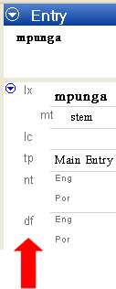

Steps to minimize and restore panes
Some splitter bars offer the ability to jump back to a previous position after having been dragged to an outer limit. These are marked with an arrow icon () when they are in an outer limit position.
- In Sena 1, go to the Lexicon area, and then click Lexicon Edit.
Make sure your Language Explorer window is maximized () to use your whole computer screen.
      - Drag the vertical splitter bar that divides the Entries pane and the Entry pane all the way to the far right of the screen. Only the Entries pane will remain visible. The splitter bar will change to show an arrow icon ()at the top of the bar.
      - To restore the Entry pane, do the following: Move the mouse pointer over the splitter bar, anywhere on or below the arrow icon. Click the splitter bar (the arrow icon itself, the word Details below the arrow icon, or anywhere below them) with a single left mouse click. The splitter bar will jump back to its original position before you dragged it to the far right. Both the Entries and Entry panes are visible again.
- Repeat the steps above, dragging the splitter to the far left of the Entries pane. Only the Entry pane will be visible. Click the splitter bar to restore the pane configuration as it was before dragging (or click the arrow icon).
Note: Not all splitter bars have this functionality. In general, only splitter bars that divide between browse and detail views have the ability to jump back to a previous position on the screen.

Customizing What You See in a Pane
Generally speaking, most panes (or views) can be customized to limit or expand how much information you see. This can be very helpful when you want to focus only on certain aspects of your data at a particular time.

Customizing the Navigation Pane
As mentioned in a previous section, you can move the splitter bar to reduce (or increase) the width of the Navigation Pane. You can also choose which area buttons are visible and in which order they appear.
To experiment, open Sena 1. Move the mouse pointer to the button at the bottom right corner of the Navigation Pane. It has this expand icon: . Click it to open a menu. Try different choices from this menu and observe the results.
For more detail on customizing the Navigation Pane, go to Language Explorer Help and view the topic on the Navigation Pane.

Customizing a browse view
In any browse view, for example the Entries in Lexicon Edit, you can choose which columns are visible. You can also adjust the widths of columns, and in most cases you can rearrange their left to right relative order.
- In Sena 1, go to the Lexicon area, and then click Lexicon Edit. Make sure your Language Explorer window is maximized to use your whole computer screen. Drag the vertical splitter bar to the right enough to expand the Entries pane so you can see the effects of the following steps.
      - Open the Configure Columns dialog box by pointing to Configure on the Tools menu and then clicking Columns. (You can also open this dialog box by clicking the Configure Columns icon in the top right corner of the Entries pane and choosing More Column Choices from the list.)
Observe the two panes in the dialog box. One has a list of Column Options, the other has the list of Current Columns that are being displayed at present. To hide a column from the current browse view select the column in the Current Columns pane and click the Remove button. To add a column to the current browse view, select the column in the Column Options pane and click the Add button. To change the relative order in which columns appear, select a column in the Current Columns pane and use the arrow buttons at the right of the pane to move the column up or down in order.
      - Select Glosses in the Column Options pane, and then click Add.
The Glosses column should appear in the Current Columns pane. You may see that there are now two Glosses columns in this pane. We will configure one to show English glosses and the other to show Portuguese glosses. (If you do not see two Glosses columns in the Current Columns pane, add one more using this step.)
      - Select one of the Glosses in the Current Columns pane. Click the down arrow in the Writing System field below this pane, and then select English.
The Glosses column you selected should now show English as the Writing System.
      - Select the other Glosses and configure it for Portuguese in the same manner.
Note that two of the choices for Writing Systems are Default Vernacular and Default Analysis. These defaults are specified in the Writing Systems tab of the Project Properties dialog box. (See Language Explorer Help for more information on configuring Writing Systems.)
      - If Grammatical Info. (Full) does not appear in the Current Columns pane, add it from the Column Options pane.
      - Use the arrow keys at the right of the dialog box to order the columns accordingly: Headword, Lexeme, Grammatical Info. (Full), Glosses(Eng), Glosses(Por).
      - Click OK.
Observe the Entries pane and see that the columns you just configured appear in the order you specified.
Apart from using the Configure Columns dialog box, you can adjust columns directly on your screen. To reorder the columns, drag and drop the column header labels to the positions you want. To adjust the width of a column, move the mouse pointer to the margin of the column header and drag the margin to the width you want to see.
Tip: The blue triangle () in a column heading indicates that the current sort is on that column.

Customizing a detail view
In any detail view you can configure which fields are visible and which are hidden. There are more fields available for lexical entries than will fit in one computer screen. Therefore, it is helpful to limit which fields are visible in order to avoid tedious scrolling.

Steps for hiding fields
At some point in his analysis, Mark decided to focus on filling in pronunciation fields for his lexical entries. He also wanted to flesh out definitions and provide example sentences. He decided to hide all the fields in the Entry pane except for the ones that were relevant to this task.
- Open the Sena 1 project (Open on the File menu), if it is not already open. Go to the Lexicon, and then click Lexicon Edit. Adjust the splitter bar to show enough of the Entry pane to see the effects of the steps below.
- If the Show Hidden Fields check box on the Entry pane title bar is selected (has a check mark), click the check box to clear it (remove the check mark).
      - In the Entry pane, click the field label Entry Type.
A small arrow icon (referred to as a "menu button") appears to the left of the Entry Type field label. (Tip: You can also use this menu button to see User Helps for the current field.)
      - Click the menu button, point to Field Visibility, and then click Normally Hidden.
The Entry Type field disappears from view.
      - In the same way, hide Summary Definition.
      - Under Sense, hide the Lexical Relations fields.
      - Continue to hide fields until the only ones visible are: Lexeme Form, Morph Type, Citation Form, Gloss, Definition, Grammatical Info, and Example.

Steps for showing hidden fields
The first time you use Language Explorer, the initial visibility setting for many lexical entry fields is Normally hidden, unless non-empty. This is the case for the Pronunciation field. Since Mark wants to focus on filling these in he would like to make these fields Always visible.
      - On the right side of the Entry pane’s Information bar, select the Show Hidden Fields check box. (The check box should have a check mark.)
All the fields that are available for lexical entries in Language Explorer are now shown in the Entry pane.
If you wish, scroll down the pane to see the range of information you can record for any given lexeme. For a description of a given field, right click the field label and select Help…. Some projects will only use a subset of all the available fields.
      - Find the Pronunciation field, which is near the top, just below Entry Type. Right click Pronunciation, point to Field Visibility, and then select Always visible.
      - Clear the Show Hidden Fields check box.
The view reverts to showing data according to field visibility settings. Notice that Pronunciation now continues to appear, slightly below Citation Form.

Steps for hiding fields unless they contain data
There are many fields that may only be used occasionally, such as the numerous note fields. In such cases, it is nicer to not see the field, unless it has information in it. The field visibility setting to use for this is Normally hidden, unless non-empty.
Though Mark only had phonology and/or grammar notes for half of his entries, he wanted to see these notes while working on pronunciations and definitions.
      - Select Show Hidden Fields to display all the fields.
      - Scroll down to Grammar Note, right click it and configure its visibility to Normally hidden, unless non-empty.
      - Do the same for Phonology Note.
      - In the Grammar Note and Phonology Note fields type this is a test note.
      - Clear the Show Hidden Fields check box.
Notice that the Grammar Note and Phonology Note fields are visible, showing the data you just typed.
Browse other entries and observe that the Grammar Note and Phonology Note fields do not appear when there are no notes to show.
For more information on how to customize the Language Explorer screen, see Language Explorer Help.

Finding Entries
When your database becomes very large, it will become more tedious to scroll the Entries pane to find a particular entry. Language Explorer provides tools to help you move through your data efficiently. The Sena 3 project larger, so we will open that project (Sena 3) for the steps below.

Moving between entries using the navigation buttons
- Open the Sena 3 project (Click Open on the File menu.). Go to the Lexicon, and then select Lexicon Edit.
Use the navigation buttons on the Standard toolbar. These allow you to go to the first entry, the previous entry, the next entry and the last entry in the database.

First Entry
Previous Entry
Next Entry
Last Entry

      - Click the Next Entry button to go to the next entry in the database.
      - Click the Previous Entry button to go to the previous entry in the database.
      - Click the Last Entry button to go to the final entry.
      - Click the First Entry button to go to the first entry.

Moving to an entry using the Find Lexical Entry dialog box
      - In the Sena 3 database, on the toolbar, click (the Find a lexical entry icon) to open the Find Lexical Entry dialog box.
(Alternatively, you can click Find lexical entry on the Edit menu, or on the keyboard, press, Ctrl+F.)
      - In the Find box, type cik.
Language Explorer will look up entries that begin with cik and display them in the Lexical Entries window of the dialog box.
      - Click ntima in the Lexical Entries pane, and then click Go To.
Notice that ntima is now selected in the Entries pane and is displayed in the Entry pane.
Note that there is also an option to create a new entry from the Find Lexical Entry dialog box. You may discover that the entry you are trying to find does not exist in your data yet. If so, click Create instead of Go To. The New Entry dialog box will appear.
Using Find Lexical Entry to enter new lexemes may be a useful strategy to avoid creating duplicates. As you type the entry in the Find field, you may discover you already have the entry in your database. Select the entry, and then click Go To so you can add any additional information you may have.
For more detail on using Find Lexical Entry, consult Language Explorer Help.

Module SF: Sorting and Filtering Data
In order to see patterns in data, it is important to be able to organize and arrange it in different ways. For example, sorting words based on the end of the word can help you discover suffixes.

Sorting Data
In Language Explorer, any browse view can be sorted in multiple ways. To sort by gloss, for example, one simply clicks the Glosses column header in a browse view. The following exercise will illustrate the different ways you can sort data.
- Open the Sena 3 project. Go to the Lexicon, and then click Browse. Using the Configure Columns dialog box, configure the browse view to show the following columns in the following order: Headword, Lexeme Form, Glosses (Eng), Glosses (Por), and Grammatical Info. (Full). (For instruction on configuring columns, see Customizing a browse view in Customizing Views and Navigation.)
      - Click the Headword column header to sort all entries by headword.
A triangle appears in the header, indicating the sort order, whether ascending or descending. When the triangle icon points down, records are sorted alphabetically starting with the last entry at the top of the list. When the triangle icon points up, records are sorted starting with the first entry at the top of the list. Observe the order in which the entries appear. They should be sorted alphabetically by headword.
Note: The alphabetical sort order is a property of the Writing System. The standard Unicode sort order is the default. See Language Explorer Help under the Writing Systems topic to see how to modify the sort order.
      - Click the Headword column header again to reverse the sort order.
Note the direction of the triangle and the order of the entries.
      - Repeat steps 1 and 2 for the Glosses (Eng) column and observe the results.
      - Click on the Lexeme Form column header to sort by lexeme form.
      - Right-click the Lexeme column header, and then select the Sorted From End check box to sort according to the end of the lexeme.
The justification of the content in that column reverses to indicate that the data is now sorted from the trailing end.
      - Left-click the Lexeme column header and notice that the sort order reverses, however lexemes are still sorted by the end of the lexeme.
      - Right-click the Lexeme column header, and then uncheck the Sorted From End check box by clicking it.
Lexemes will again be sorted alphabetically according to the beginning (leading) characters.
For more information on how sorting affects the display of data, see Language Explorer Help, Basic Tasks \ Sorting Data. Of particular interest is the section on sorting lexical entries.

Filtering Data
You can view subsets of your data by applying filters to various columns in a browse view. For example, to find lexemes where no gloss is recorded yet you could filter on blank gloss fields. Alternatively, to analyze where a certain morpheme break should occur you can filter on character sequences. The following exercise will illustrate different ways you can filter data.
- Open the Sena 3 project. Go to the Lexicon, and then click Browse. Using the Configure Columns dialog box, configure the browse view to show the following columns in the following order: Headword, Lexeme, Glosses (Eng), Glosses (Por), and Grammatical Info. (Full). (For instruction on configuring columns, see Customizing a browse view in Customizing Views and Navigation.)

Using the preconfigured filters
      - In the Grammatical Info column, click the down arrow just under a column heading.
A list appears with list filter options you can select. (Show All is the default unfiltered view.)
      - In the list, select Blanks.
Only the lexical entries with blank Grammatical Info fields appear on the screen.

Important concepts:
Notice on the status bar in the lower right corner of the screen the word Filtered appears and is highlighted. This indicates that what you see in the browse view is a subset of the database. This is handy in cases where it may not be obvious from the data displayed that a filter is active.
Notice also the current record/total records display in the bottom right corner of the screen. The number before the slash is the order number of the selected entry according to the current primary sort. The number after the slash is the total number of records being displayed in the browse view, again according to the current sort. When a filter is active, you can see how many records match the filter by observing this number. For example, Filtered 3/257 indicates that 257 records match the filter and that the currently selected record is the 3rd record from the top of the list. In steps that follow, take note of how the record number/total records display changes as you apply and remove filters.
You need to understand that in Lexicon Edit or Browse, the current record/total records values depend on the primary sort. If the primary sort column belongs to the entry (such as Lexeme Form), the values are entry counts. If the primary sort column belongs to the senses, (such as Definitions), then the values are sense counts.
In the first case, each row displayed is an entry and the values reflect any filters used. Entries are not displayed more than one time even if more than one sense matches filter criterion.
In the second case, each row displayed is a separate sense whose content matches the filter criterion. So, you may see separate rows for senses from a single entry, if multiple senses match the filter criterion.
Correspondingly, in Bulk Edit Entries, the values reflect entry counts, whereas in Bulk Edit Senses the values reflect sense counts.
      - Click the down arrow under the Grammatical Info column header and select Show All.
All the lexical entries become visible again.
The only preconfigured filters available are Blanks and Non-blanks. Non-blanks will exclude data where the filtered field is empty. In other columns there are other options that you configure. For example, in columns that contain only numerical values there is a Restrict option, and in columns that contain list items there is a Choose option.

Filtering on character sequences
Another option in the filter drop down list is Filter for. Selecting this will open the Filter for items containing dialog box. You can use this feature to filter on character sequences and various other criteria such as case and position in the word.
      - Click the down arrow below the Grammatical Info column heading, and then select Filter for.
The Filter for items containing dialog box appears.
      - In the Enter text to search for box, type Nome. (Nome is the Portuguese equivalent for Noun.)
Leave the option Anywhere selected. Leave Match case and Match diacritics cleared.
      - Click OK.
Now, only the lexemes that are classified as Nome are visible in the browse view.
You can apply filters to more than one column at a time.
      - Under the Headword column, open the Filter for items containing dialog box. (Click the down arrow below the Headword column heading, and then click Filter for.)
      - In the Enter text to search for box, type mb.
      - Select At start to filter for mb at the beginning of words.
Leave Match case and Match diacritics cleared.
      - Click OK.
Now only Headwords that begin with mb, and which are classified as Nome are visible.
When two or more filters are active, it can be tedious to turn them all off one by one by selecting Show All under each filtered column header. To turn off all filters at once there is a control on the toolbar.
      - To turn off all the filters, click the Turn off all filters icon on the toolbar. Alternatively, on the View menu, point to Filters, and then click No Filter. Now all lexical entries are visible in the browse view again.
To learn more about filters, see the topic on filtering data under Basic Tasks in Language Explorer Help. Of particular interest is the use of regular expressions.

Module BE: Editing Data Using Bulk Edit
In previous modules, we discussed how to enter, edit and delete data on an entry-by-entry basis. In general, one edits the information in entries using a detail view such as the Entry pane in the Lexicon Edit tool. There are some situations however where the same action needs to be taken on many records. It would be handy to select all the records that need the particular edit and then do the action once for all of them simultaneously. The Bulk Edit tools offer this functionality.
A full description of Bulk Edit features is beyond the scope of this manual. We will do a simple Bulk Edit action in this module as an example to introduce the concept.

Using Bulk Edit to copy information from one field to another
After entering many new words into his database using the Categorized Entry tool, Mark would like to populate the Gloss field from the Definition field.
- Open Sena 1 and go to the Lexicon, and then click Bulk Edit Entries. (Note, make sure you have completed the Entering Data module before doing this exercise.)
Note that Bulk Edit operates on a browse view of your data. As such, you can configure columns, sort and filter as you would any browse view. In this way, you can narrow down which data you will act on when you perform a Bulk Edit operation.
      - Filter on the Gloss field to show only blank fields. (See Filtering Data for instructions on how to do this.)
The only entries that appear should be the ones without glosses now.
If we indeed had a large database, we might also filter on Definition for Non-blanks to further narrow down the data we act on. In this example, it is not necessary.
      - Click the Bulk Copy tab at the bottom of the screen.
      - In the Source Field box, select Definition.
      - In the Target Field box, select Glosses.
Bulk Copy is now set up to copy the information in the Definition field to the Gloss field of every check-marked entry in the browse view pane.
To exclude an entry from the Bulk Edit operation, uncheck the check box for that entry.
      - Click Preview to see what will happen if you proceed with the Bulk Copy operation.
The contents of the Definition fields should appear in the Gloss fields with arrows to the left of each gloss. The arrows indicate the change that will happen if you press the Apply button.
It is advisable to press Preview before applying any Bulk Edit operation in order to check and make sure the change is what you want. If the change is not what you want, press the Clear button (the Preview button changes to Clear after you click it) and adjust the Bulk Edit parameters as needed.
      - Click the Apply button to perform the Bulk Copy.

Summary - General process to follow for using Bulk Copy
The bulk edit tools (Bulk Edit Entries, Bulk Edit Senses, and Bulk Edit Reversal Entries) in Language Explorer offer an efficient way to edit data one field at a time rather than one entry at a time. In general, for any bulk edit operation follow the steps below:
      - Select the bulk edit tool that pertains to the information you want to operate on.
      - Configure the browse view to show the columns you need for filtering and editing data.
      - Apply filters to narrow down the subset of data you want to operate on.
      - Uncheck entries that you want to further exclude from the operation. Depending on the number of rows in the window, you will often use the check box feature to select all rows, clear all rows or to toggle the selected/cleared rows.
      - Choose the bulk edit operation you want to apply (select a tab at the bottom of the screen) and set the parameters of the operation.
      - Preview the changes that will take place if you follow through with the operation. If the changes are not what you want, press the Clear button and adjust the parameters.
      - Press Apply to carry out the operation.
To learn the many other Bulk Edit operations available, see Bulk Edit Senses and Bulk Edit Entries under Lexicon Tools in Language Explorer Help. For more insight in how to use Bulk Edit tools in tandem with rapid dictionary development, see Introduction to Lexicography, which is under Resources in the Help menu.

Module SD: Sharing Data
Making data available to others is an important aspect of any project. Typical reasons people share data:
- To collaborate with fellow coworkers.
- To have a consultant check their work.
- To have a committee review work done on a dictionary.
- To publish information either in print or on the web.
In the following sections, we will discuss sharing database files, printing from Language Explorer and exporting data for use in other software.

Transferring Data to another Computer
The best way to transfer a FieldWorks project from one computer to another is to use Backup and Restore. See Using Back and Restore for instructions.

Steps to put a copy of a project on another computer
      - Backup the Sena 3 project on the original computer.
      - Save a copy of the backup file on external media.
      - Transfer the backup file to the second computer.
      - Start Language Explorer on the second computer, and then restore the project from the backup file.
(The same version of FieldWorks must be installed on the second computer as was used to create the backup on the first computer.)
You may need to copy other files to the second computer for your project to display properly. Files such as fonts, Keyman keyboards, etc. are not backed up as part of the FieldWorks project. See Files that FieldWorks does not back up under Backup and Restore in Language Explorer Help for full information.
For more information on collaboration, see Collaborating with Others under Basic Tasks in Language Explorer Help.

Printing Configured Dictionary Data
One of the projects Mark wanted to do was produce a simple Sena dictionary with Portuguese and English glosses. This would be published for the Sena elementary school system. Mark was working with a dictionary committee and needed to print out a subset of dictionary entries for their review. He used filters to isolate the b section of the dictionary. He then used Dictionary features to configure the dictionary view. Mark wanted the printout to include the Sena headword, the grammatical information, and the Portuguese and English glosses. Once he produced this view in Language Explorer, he printed out hard copies for the committee to use.

Steps to configure and print out dictionary entries
- Open Sena 3 and go to the Lexicon, and then click Lexicon Edit. Filter on entries that begin with the letter b by applying a filter in the Headword column in the Entries pane. (See Filtering Data for instructions.) Only words starting in b should now appear in the Entries pane.
      - In the Navigation Pane, click Dictionary.
Notice that only the b section of the dictionary is visible.
      - On the Tools menu, point to Configure, and then click Dictionary to open the Configure Dictionary View dialog box.
      - Make sure that Stem-based appears in the Choose dictionary view to configure box.
The Configure pane shows a hierarchical list of items (fields and field groups). Those with a check box are displayed in the dictionary; those with a cleared check box are not displayed.
In the hierarchical list, you can expand any item that has a (plus sign). However, if the check box for that item is cleared, then no item under it will be displayed in the dictionary. Therefore, you do not need to expand every item and clear every check box. For example, if you clear the check box for Pronunciations, then Pronunciation, CV Pattern, and Tone will not appear in the view even if they have check marks.
Correspondingly, if you want to display an item at a lower hierarchical level, then parent item(s) needs to be checked. For example, to display Grammatical Info, Senses must have a check mark.
      - In the Configure pane, under Main Entry clear the check box on each item that we do not want to display in the dictionary view. In this case, we need to have check marks on the following items: Headword, Senses, and Grammatical Info and Gloss (both are under Senses). (Note: The next page has a picture of the dialog box.)
      - Under Senses, expand Grammatical Info to show the items under it (Category Info, Slots and so on). Then make sure each item has a check mark.
      - Also under Sense, select the Gloss, that is select its name like this .
The right pane now has Senses: Gloss at the top, with various boxes and options you can use to configure how Gloss field content will appear.
      - By default, the Display if data present check box has a check mark. Make sure this check box has a check mark in your dialog box.
      - In the Writing Systems pane, make sure Portuguese and English have check marks.
For this exercise, we will not select a character style or add any surrounding content to the display. However, you can return later to experiment with these features.
      - By default, the Display Writing System Abbreviation check box has a check mark. Make sure this check box has a check mark in your dialog box. This will allow Por and Eng to appear next to the glosses to identify the writing systems.
The upper portion of your Configure pane should look like this:
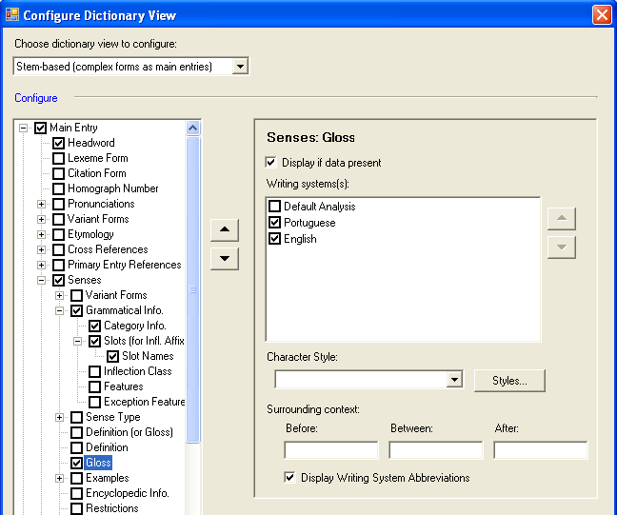
(You can select Inflection Class, Features and Exception Features under Grammatical Info if you want to. It is optional for this exercise.)
      - Next, click (minus sign) to collapse Main Entries, and then click to expand Minor Entry.
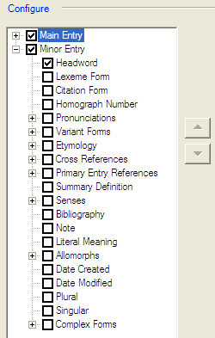
      - Clear the check mark from each top-level check box under Minor Entry, except for Headword.
Your Configure pane should look like this:

      - Click OK at the bottom of the Configure Dictionary dialog box.
The dictionary view now has all the Sena 3 words that start with b, and includes the grammatical category, Portuguese gloss and English gloss for each word. Some entries have more than one sense. For those, you see the sense number appearing with the glosses. For example,
      - On the File menu, click Print to print this section of the dictionary.

Summary for printing dictionary data
To print dictionary data you must configure a dictionary view in the Dictionary tool and use File_Print.
      - In Lexicon Edit or Browse, use filters to choose the entries that will appear in the Dictionary Entries pane. Sort the entries according to how you want them to print.
      - Open the Dictionary tool. Examine the view to make sure the entries you want to print appear in the order you want them in.
      - Use the Configure Dictionary View dialog box to choose which fields to show and in what order to show them for each entry.
      - When the data is arranged to your satisfaction in the Dictionary Entries pane, use File_Print to print it out.
The Configure Dictionary View dialog box offers formatting capability to produce good draft output for more complex dictionaries as well. See Configure Dictionary View dialog box in Language Explorer Help for detailed instructions.

Printing text data
Printing text data is similar to printing dictionary data in that first you configure a view of the data and then print that view using the File_Print menu command.
- Open Sena 3 and go to the Texts & Words area, click Interlinear Texts, and then click the desired text in the Texts pane. In the Text pane, click the Print View tab.
The selected text will appear in an interlinear format in the Text pane Print View tab.
      - Open the Configure Interlinear Lines dialog box (on the Tools menu, point to Configure, and then click Interlinear).
      - Configure the lines such that the following lines appear in the following order: Word, Word Gloss, and Free Translation. (See Steps to interlinearize a text for sample steps to configure interlinear lines.)
- To see the sufficient data in the print, set Word Gloss and Free Translation to use the English writing system, or optionally, show two Word Gloss and two Free Translation lines, with one set to use Portuguese and the other to use English.
      - Click OK.
The Text pane now displays the text with Word Glosses and Free Translation.
      - On the File menu, click Print to print out the text.

Exporting Data
When Mark put the finishing touches on the Sena dictionary for the elementary school system, he needed to have it typeset and published. Since Language Explorer does not provide typesetting capability, he needed to export the data to a format a publishing house could use. He chose to export the dictionary to XML format.

Exporting a configured dictionary to XML
- Configure a dictionary view of the Sena 3 database such that each entry includes the Sena word, the grammatical information and the Portuguese and English glosses. To accomplish this, follow the instructions in Steps to print out dictionary entries with the exception of applying filters. (We want all entries to appear, not just the b section.) Of course, you will not need to print this view, so skip the last step.
      - All Sena 3 entries should appear in the Entries pane in the Dictionary. (Make sure the Dictionary view is selected in the Navigation pane.) Open the Export dialog box (click Export Lexicon on the File menu).
      - Select the Configured Dictionary XML option, and then click the Export button.
The Export to XML dialog box appears.
      - Choose a folder in the Save in field where you can find the exported file later. If you have a My FieldWorks subfolder in your My Documents folder, this would be a logical choice.
      - In the File name field, type Sena 3 trilingual dictionary, leave the Save as type: XML, and then click Save.
The configured dictionary will be exported.
      - Verify that the exported file was created by going to the folder you saved it to and looking for the file.
You can right-click the file and select Open with_WordPad to read the file. Someone who knows how to manipulate XML files can transform your data into something that can be typeset for publication.
You can export a configured dictionary to SFM format as well. Follow the same steps above, only select Configured Dictionary SFM option in the Export dialog box. When you open the resulting file in WordPad, you will see your data in SFM format with MDF style backslash codes.

Exporting a lexical database to MDF format
The third option in the Export dialog box (click Export Lexicon on the File menu) is Lexicon MDF Standard Format. One of the best uses of this option is to publish your dictionary on the web using Lexique Pro (discussed in the user Helps).

Exporting interlinear text
You can export interlinear text for use in other documents such as research papers or reports. The general procedure is as follows:
      - Open your project in Language Explorer and go to the Texts & Words area. Make sure your interlinear analysis is as complete as you want it before exporting.
      - Use the Configure Interlinear Lines dialog box (on the Tools menu, point to Configure, and then click Interlinear) to configure the analysis lines you want to appear in the exported text.
      - Open the Export dialog box (click Export Interlinear on the File menu), and then do the following:
        - If you primarily want to display your text in a web browser, select the HTML option.
        - If you will be using your own XSLT transforms to render your text, select the Interlinear XML option.
        - If you want to incorporate interlinear text in an Open Office document, select the Open Office Writer option.
        - If you want to incorporate interlinear text in a Word document, select the Microsoft Word XML option.
Note that after exporting you will need to run a macro to adjust things. See the instructions in the dialog box or User Help file.
        - If you want to incorporate interlinear text in an XLingPap document, select the appropriate XLingPap method.
      - Click Export to save the exported file to the folder of your choice.

Module HR: Using Help and Other Resources
This manual is intended to help users get started using Language Explorer. We covered the basics of creating a FieldWorks project, entering and editing data, navigating the different areas and views (panes) of the program, and several other features. However, there is far more that you can do with Language Explorer than is covered in this manual. To help you understand and use the full power of Language Explorer, other resources are provided.

Language Explorer Help
Help is available using the Help menu or using the many context sensitive help buttons in dialog boxes. Help is also available for each data field in the database.

Accessing online help
      - On the Help menu, click Language Explorer.
The FieldWorks Language Explorer Help window appears.
      - Use the Help navigation pane to find the topic you want.
      - Read about the topic in the Help content pane, clicking the hyperlinks as needed to follow the paths to other related topics.

Accessing context sensitive help
Within various dialog boxes and popup menus there are help buttons displayed. Simply click the Help button to bring up the Language Explorer Help window. The topic relevant to the dialog box will appear in the Help Content window.

Accessing help on data fields
There are many data fields available for recording information in Language Explorer. This is especially the case for the Lexicon Edit tool. As you enter data, it may not be clear what a particular field should be used for. To help you with this, full descriptions of each field are located in Language Explorer Help. They can be accessed by right clicking the field label of interest. In the following exercise, we will find help on the Citation Form field.
- Open Language Explorer. Go to the Lexicon, and then click Lexicon Edit.
      - In the Entry pane, right-click the Citation Form field label.
A drop-down menu appears.
      - Click Help.
The Language Explorer Help window appears showing the Citation Form field topic in the Content pane.
Notice the format of the content. Typically, every field description will include: Full name, Abbreviation, Description, Field type, and Writing system used.
      - Read about the Citation Form field and then close the Help window.

Demo Movies
A number of demonstration movies are available to illustrate the major functions of Language Explorer. You may select any movie of interest individually. Or you may opt to watch them all, one after another, in order to get an in depth overview of how Language Explorer works. Each movie is less than 3 minutes long. The entire set can be viewed within half an hour.

Resources
The following resources provide more in-depth detail on various topics. You can access those under the Resources option on the Help menu, or on the start menu: Start\ Programs\FieldWorks Language Explorer\Resources.

Introduction to Lexicography
This document describes some of the concepts, principles, and procedures of dictionary making and how to use Language Explorer to efficiently collect and process dictionary information.

Introduction to Parsing
This document introduces the Language Explorer approach to morphological parsing.

Technical Notes on SFM Database Import
This document gives instructions on how to import data from a SFM database.

Technical Notes on LinguaLinks Import
This document gives instructions on how to import data from a LinguaLinks database.

Technical Notes on Writing Systems
This document goes into greater detail than Language Explorer Help regarding Writing Systems and how to configure them.

Editing Linguistics Papers Using XLingPap
This document describes how to use the XLingPap package as an aid for linguists as they write linguistic papers.

Appendices

Appendix DW - Defining a new vernacular writing system
If you need to set up a new FieldWorks project and also define a new vernacular writing system, we recommend that you give the project and the writing system the name of the vernacular language.
In the following example, the name of the vernacular language is Swati.
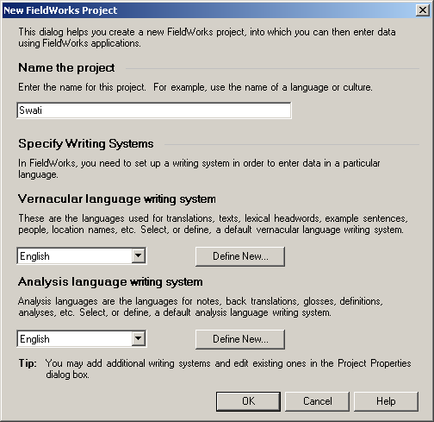
      - On the File menu, click New Fieldworks Project.
The New FieldWorks Project dialog box appears.
      - In the Name the project box, type Swati.
      - Under Vernacular language writing system, verify that Swati is not already in the list.
      - Under Vernacular language writing system, click Define New.

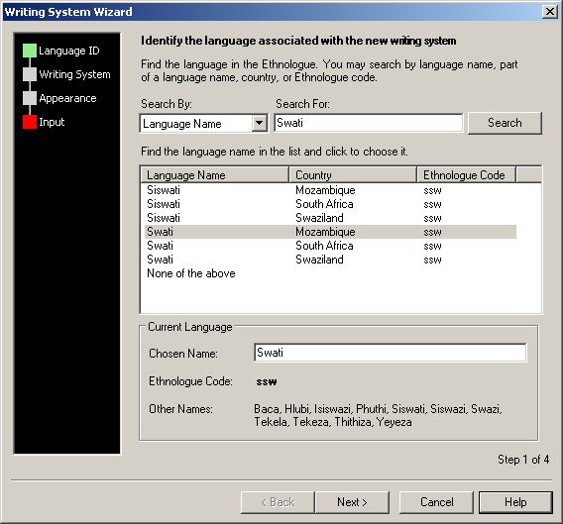
The Writing System Wizard dialog box appears. If the name of the project matches any languages in the Ethnologue, all the matches appear in the list.

      - Select the correct language and country in the list (for example, Swati and Mozambique).

      - Click Next three times.
      - Click Finish.
The New FieldWorks Project dialog box appears again. Under Vernacular language writing system, Swati appears in the list.

On the Writing System Wizard dialog box, click Help. The FieldWorks Language Explorer Help window appears. For more information about defining a writing system, read the Help topic. To read related topics, click the hyperlinks. To see related topics, you can also click the Contents tab of the Help Navigation Pane.

Appendix AC – About Anthropology Categories
The Anthropology Categories field is a list reference field in Language Explorer. The list is comprised of two complementary but distinct topical classification systems for cultural data: Framework for Anthropology and Methodology in Ethnography, or FRAME (SIL International), and the Outline of Cultural Materials, or OCM (HRAF, Inc.).

What is the Outline of Cultural Materials?
The Outline of Cultural Materials (OCM) is a numerical classification system for categorizing cultural data. It was developed by the anthropologist George Peter Murdock and his colleagues for use with the Human Resource Area Files (Yale University). It is usually referred to by its initials, OCM

Cultural classification

Types of categories
In the OCM, there are major categories and subcategories. Both types may be used to categorize data.
There are 83 major categories, which range from 100 to 910. Each major category has multiple subcategories. There are more than 700 subcategories in the OCM.
The first two digits in an OCM code followed by a “0” represent major categories.
Subcategories are represented by the third, or third and forth digits of the OCM code, which replace the “0” of the major category.

Example
A major OCM category and its subcategories:
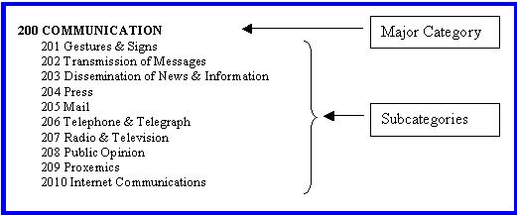

Example
Each OCM category includes a description and cross-references:
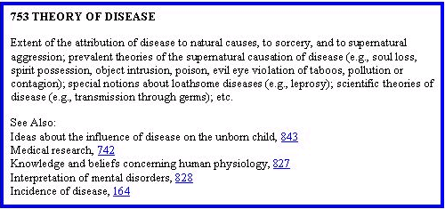

A note about HRAF
The OCM is sometimes erroneously referred to as H-RAF, the HRAF codes, or the Human Relations Area Files system. Although they are related, these should not be confused. The HRAF is a collection of subject-index ethnographic and archaeological data developed for purposes of comparative research. HRAF, Inc. is a not-for-profit international consortium of educational and research institutions. See http://www.Yale.edu/hraf.

Parts of the OCM manual
Here are the parts of the Outline of Cultural Materials:
- Preface and Introduction to the OCM system
- Table of Contents, which lists the major categories and subcategories and their numerical classification codes
- Descriptions of each category with guidelines about what kinds of things can be included under a particular category
- Index of key words cross-referenced to relevant categories

Framework for Research and Methodology in Ethnography (FRAME)

Description
The Framework for Research and Methodology in Ethnography (FRAME) is a top-level outline of eleven subjects under which the categories of the Outline of Cultural Materials (OCM) can be grouped. FRAME was developed by SIL International for use in FieldWorks.
FRAME summarizes and simplifies the more definitive categories of the OCM. It is intended to facilitate access to the OCM for field researchers in the process of language and culture learning. While FRAME categories may be used in research, you are encouraged to use the major categories and subcategories of the OCM when entering data in the Anthropology Category field.

Example of a FRAME category

SG Social Groups
Code and title for FRAME category

Description
Use the SG Social Groups
to find OCM categories for more specific classification about this topic.
to categorize information about how people define family relationships, how family members should interact, marriage, extended families, and kin groups.
How to apply and use FRAME category

Categories
Here are the categories under Social Groups:
570 Interpersonal Relations
580 Marriage
590 Family
Major OCM categories that pertain to the “SG Social Groups” FRAME category
600 Kinship
610 Kin Groups

Appendix SD – About Semantic Domains
The Semantic Domains list is used to categorize lexical entries. You can categorize existing lexical entries by choosing items in the Semantic Domains field. However, you can also use them to collect word using the Categorized Entry tool. This is the reason for the questions and examples included with each list item.

Lexical entries categorized with semantic domains appear in the Classified Dictionary view.

Index

areas, 5
backup. See data
baseline tab, 29
bulk edit. See editing data
categorized entry. See entry
Configure
Configure Dictionary View, 59
configure columns. See view
configure interlinear. See view
data
backing up data, 41
exporting data (SFM), 63
exporting data (XML), 62
exporting text data, 63
printing configured dictionary data, 59
restoring data, 43
transferring a database to another computer, 58
editing data
bulk edit, 56
editable fields, 6
entry, 20
categorized entry of lexical data, 25
creating a new lexical entry, 17, 20
creating a new text, 27, 28
deleting entries, 19
export. See data
field, 6
field visibility, 49
FieldWorks project. See Project
filter, 53
find, 50
FRAME, 71
grammar area, 6
Help, 34, 65
demo movies, 66
Help menu, 6
Resources, 65, 66
list area, 6
Navigation between entries, 45
OCM, 69
Outline of Cultural Materials, 69
pane, 5, 6
customizing pane size, 45
print. See data
Project
new, 8
open, 9, 15
restore. See data
Semantic Domains field, 72
sort, 52
Sort
sort by leading characters, 52
sort by training characters, 52
text
exporting, 63
interlinearize, 29
record, 29
vernacular writing system. See writing systems
view
customizing columns, 47
customizing field visibility, 49
customizing interlinear analysis lines, 29
customizing pane size, 45
data entry, 17
display panes or views, 6
writing systems, 67
vernacular, 11, 67

